FieldWorks
Language Explorer

FieldWorks Version 7
Student Manual



DRAFT; under development.

Copyright © 2010-2011 SIL International

Contents
Contents 2
Introduction 4
Anatomy of a Language Explorer Screen 5
How to use this manual 7
Module SU: Setting Up a New Fieldworks Project 8
Setting up a new FieldWorks project 9
Module ED: Entering Data 14
Creating a New Lexical Entry – a simple example 14
Creating a New Lexical Entry – a realistic example 17
Adding New Senses 19
Entering Semantically Categorized Lexical Data 22
Entering Text Data – basic steps 24
Entering Text Data – a realistic example 26
Tagging a text 31
Module DC: Discourse Chart (Text Chart tab) 33
Practice inserting text into the chart 33
Practice with Text Chart menu commands 34
Module PM: Project Management 39
Backing up a FieldWorks project 39
Restoring a FieldWorks project 41
Module VN: Viewing and Navigating Data 42
Adjusting Pane Sizes 42
Customizing What You See in a Pane 44
Finding Entries 47
Module SF: Sorting and Filtering Data 49
Sorting Data 49
Filtering Data 50
Module BE: Editing Data Using Bulk Edit 53
Using Bulk Edit to copy information from one field to another 53
Summary - General process to follow for using Bulk Copy 54
Module SD: Sharing Data 55
Transferring Data to another Computer 55
Printing Configured Dictionary Data 56
Exporting Data 59
Module NB: Notebook area 61
About the Notebook area 62
Module ND: Entering Notebook Data 63
Scenario A: Writing fieldnote records 63
Scenario B: Breaking a long entry into subrecords 69
Steps to add subrecords 69
Promote, Demote, Move records and subrecords 72
Scenario C: Reviewing a lot of fieldnotes in Notebook 74
Scenario D: Insert a custom list 82
Scenario E: Insert a custom list reference field 83
Module DM: Dealing With Multilanguage Data 84
Scenario A: Entering vernacular text in a fieldnote 85
Scenario B: Writing a fieldnote in a different language 88
Module AD: Altering Data 93
Scenario A: Adding data 93
Scenario B: Correcting data 95
Module DQ: Using Your Data to Generate Research Questions 97
Scenario: Recording further questions 97
Module CE: Categorizing Fieldnote Records 99
Scenario: Adding OCM codes using search and index features 100
Module HR: Using Help and Other Resources 107
Language Explorer Help 107
Demo Movies 108
Resources 108
Appendices 109
Appendix DW - Defining a new vernacular writing system 109
Appendix AC – About Anthropology Categories 111
Appendix SD – About Semantic Domains 114
Appendix TF – Title field writing systems 115
Index 116

Introduction
FieldWorks Language Explorer facilitates the recording and analysis of linguistic data and anthropological data. Once a FieldWorks project is created for the language under study, Language Explorer provides a well-ordered set of fields to record data. It also provides a means of recording a text corpus with the built-in capability to interlinearize text. Running an optional automated morphological parser can make interlinearizing text an efficient task. Grammar tools are also available which allow the user to capture grammatical information. This information is used by the morphological parser, providing a way to check grammatical rules recorded against real language data. The grammar information can also be compiled in an automatically generated grammar sketch.
There are multiple ways to view and edit your data in Language Explorer. Though Language Explorer is a powerful program, you do not have to master all of its capability to start using it right away. Neither do you need to know much about the language before you can start entering data. Your linguistic database grows with your knowledge of the language, and more advanced tools within Language Explorer are available, as you need them.
- You can use Language Explorer to:
- Record lexical information for the development of a dictionary
- Rapidly enter words that were collected at a semantic domain word elicitation workshop
- Record vernacular texts and view a concordance of words within recorded texts
- Create an interlinear analysis of texts
- Analyze morphology
- Create a grammar sketch
- Record anthropological field notes

Anatomy of a Language Explorer Screen
Aside from the conventional Windows™ menu bar, toolbar, status bar, etc. Language Explorer screens are typically divided into two or more panes. The far left pane is the Navigation Pane. It is here that you choose which Language Explorer area you want to go to and which tool within the area you want to use. The other panes that are displayed depend on the area and tool you choose from within the Navigation Pane.

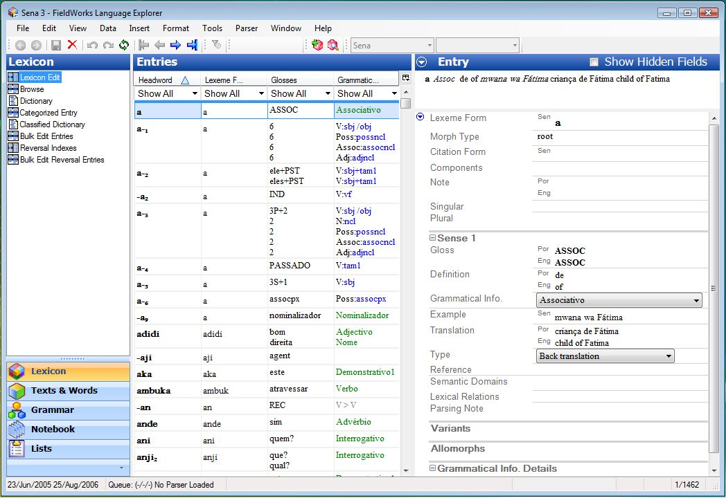
Information bar
Dictionary preview pane
Navigation Pane area buttons, and tools/views.
“Center” pane, here called Entries.
“Details” pane, here called Entry.

Language Explorer is organized around functional "areas" of language work. Within each area, specialized tools or views are available. When you start Language Explorer for the first time, the default area that you see is the Lexicon area. The Lexicon area is where you will record information on the lexemes of a language. This data can become the basis for a published dictionary.
Besides the Lexicon area, the other functional areas in Language Explorer are listed below. You can click each one and examine the area.
- Texts & Words: This is the area where you record, gloss, analyze (interlinearize) and chart text data. Also, you manage the morphological analysis of words. You can also view a concordance of any word that occurs in your text corpus.
- Grammar: This is the area where you manage inflection templates, grammatical categories, natural classes, and much more.
- Notebook: This is the area where you record and work with anthropological data (Module NB discusses this area).
- Lists: This is the area where you edit the list choices presented for certain fields in the database. Note that by default, the Lists area button is shown minimized below Notebook (at the bottom of the Navigation Pane).
In this manual, we will primarily be working with the Lexicon and Text areas for lexical data since these are where the much of one’s data entry and editing are accomplished. For anthropological data, we will discuss the Notebook area. The other areas are beyond the scope of this manual. For more information about any of these areas, go to Language Explorer Help available in the Help menu.

Panes and Views
There are basically four different kinds of display panes, or views:
- Detail view: In a detail view, every field of a selected record is viewable. For example, the Entry pane in Lexicon Edit (shown above) shows every detail of the selected lexeme. Every field in a detail view is editable.
- Browse view: In a browse view, data is displayed in columnar fashion. Each column represents a field and every row represents a record. This view shows a lot of records at a glance. The Entries pane in Lexicon Edit (shown above) is a browse view pane. Note that most fields are not editable in browse views. When a record is selected, fields that are editable are white. The rest are shaded.
- Tree list view: Data that is organized in a nested or hierarchical structure is displayed in a tree list view. For example, the middle pane of Categorized Entry (shown below) displays an organized set of semantic categories. Data displayed in a tree list view is not directly editable. However, most list data can be edited in the Lists area, or using a menu command.
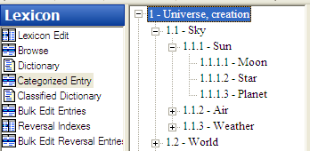
- Presentation view: In a presentation view, data is displayed as it will look when printed out. The Dictionary (in the Lexicon area) is a presentation view. Data cannot be edited directly in presentation views.
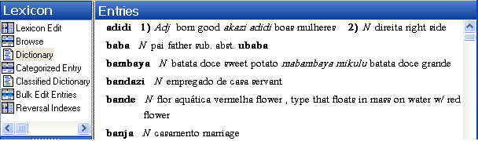

Different tools will use different combinations of these views. For example, Lexicon Edit has a browse view in the Entries pane, and a detail view in the Entry pane. At the top of the Entry pane there is the Dictionary Preview pane.
Feel free to explore at this point. Use the mouse to click one of the areas in the lower part of the Navigation Pane, and then click a tool associated with the selected area in the upper part of the Navigation Pane. Note the combination of different display panes and views in each tool.
For instructions on how to customize the layout of the Language Explorer screen, see Customizing Views and Navigation.

How to use this manual
This manual will help you get up and running using the basic features of Language Explorer. It is not a comprehensive instruction manual. For more detailed instructions on how to use a particular feature, consult Language Explorer Help or other supplied resources. (See Using Help and Other Resources.)
The best way to use this manual is to go through the chapters and exercises sequentially. You will be creating and developing a sample database as you go. Later exercises will assume you have already done earlier ones.
To give real-life context to using Language Explorer we created a fictitious researcher, Mark, who will be researching a real language, Sena.

Module SU: Setting Up a New Fieldworks Project
Mark is a linguist who is doing research on the Sena language. Sena is a Bantu language, spoken in Mozambique. The local language of wider communication is Portuguese. Mark will set up a FieldWorks project for Sena, designating Sena as the vernacular language under study, and Portuguese and English as analysis languages.
Course notes: Normally, in actual fieldwork, a researcher will only create one FieldWorks project for a given language being researched. However, for the sake of this training manual we will be dealing with several FieldWorks projects for Sena. You will create Sena 1 in this module and use it in most modules. However, in order to work with a larger database in later modules, we provide you with Sena 3. Sena 2 is also provided as a sample database. Because it is intended for use with other FieldWorks tools, it should not be changed.
Note that the Sena 3 database is based on an actual research project. Nothing is artificially contrived. You may notice numerous research notes and residue questions in various places in the data. These reflect the current state of analysis as of the date this software was released.
Follow the steps in this module to create a new FieldWorks project. Note, if you have already created Sena 1 in the process of learning another FieldWorks program, skip this module. You can simply open the Sena 1 project you created previously and go on to another module.
- To open a language project, on the File menu, click Open, and then select the language project you want to open. When the desired file appears in the File name box, click Open.
Once you have created the Sena 1 project, you can move on to another module; or if desired, exit the project.

Setting up a new FieldWorks project
      - To start Language Explorer, double-click the Language Explorer icon on the desktop.
- The very first time you do this, you will see the Training available dialog box. Click Yes to open Sena 3. Then you will see the Field Usage Report System dialog box. Click either the Create Email Message button or the I’m unable to send this information link, as appropriate.
The Sena 3 – Language Explorer window appears. After this initial startup, you will not see these dialog boxes again. Instead, the last project closed is the project that opens the next time you start Language Explorer.
In Language Explorer, you can create and open multiple FieldWorks projects. From this point on, the last FieldWorks project you close will be the one that appears the next time you start the FieldWorks Language Explorer program.
      - On the Menu bar, click File, and then click New FieldWorks Project.

The New FieldWorks Project dialog box appears.
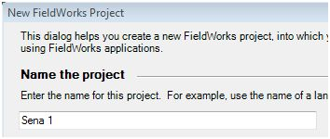
      - Type Sena 1 in the Name the project box.

Mark will use a Vernacular language writing system that has already been defined in FieldWorks.
      - In the drop-down list, select Sena as the Vernacular language writing system.

Course Note: It is important to understand the distinction between a language and a writing system in FieldWorks. Every FieldWorks project is based on one, and only one, vernacular language. (The vernacular language is the one you are researching.) However, the vernacular language may be represented graphically by one or more writing systems. For example, one writing system may be based on IPA. Another may be the official orthography of the language. Another may be a traditional orthography. For simplicity in this manual, the Sena databases will only have one Vernacular language writing system associated with vernacular data. Note that the main Vernacular language writing system used in a project will likely have the same name as the language. In Sena 1, for example, Sena is the vernacular language we are researching. Sena is also the name of the writing system we are using to enter vernacular data.

For information about setting up a new FieldWorks project and also defining a new vernacular writing system, instead of selecting a writing system that has already been defined, see page 109.
      - Mark will use Portuguese as one of the Analysis languages. So, in the drop-down list, select Portuguese as the Analysis language writing system.
      - Click OK at the bottom of the dialogue box.

An analysis language is a language in which you document analysis work, not the language that you are analyzing. You can select multiple analysis languages. In Language Explorer, glosses, definitions, and notes are in analysis languages.
Select a primary analysis language in which you express yourself well. For example, multi-cultural teams might use the language that all members know and teams with national members might use the national language.
In the Sena projects, the primary analysis language is Portuguese, and the secondary analysis language is English.
Note: The Portuguese writing system was installed with FieldWorks. If you have opened other FieldWorks applications on your computer, more writing systems might appear in the list.

The system creates the new Sena 1 – FieldWorks project. Depending on the speed of your computer, this may take several minutes. The progress box shown here appears, as well as some others (briefly), and indicate the progress.
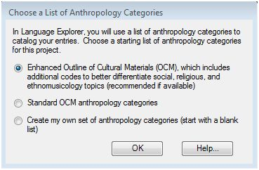
The Choose a List of Anthropology Codes dialog box appears. The set of anthropology codes you choose here will be available to you as you enter data into your lexical database. In this way you can tag your data by cultural category.

Enhanced Outline of Cultural Materials (OCM): This choice takes advantage of all the resources in the Outline of Cultural Materials. In addition, you will have available SIL’s FRAME categories that group the OCM under eleven higher-level divisions, and you will be able to use expanded categories on music, musical instruments, religion, and several other topics that are commonly elaborated.
Standard OCM anthropology categories: If you are already quite familiar with the OCM and do not envision expanding the codes, or plan on expanding them with your own additions, then you may want to use the Standard OCM anthropology categories.
Create my own set of anthropology categories: Select this option if you intend to enter your own anthropology category list, and do not ever plan to use the OCM in this project. Developing your own list of anthropology categories is easy to do badly and hard to do well. We do not recommend personal development of anthropology categories unless you have considerable experience in that area. Custom anthropology categories, while they can be developed for very specific research needs, will also limit the comparability of your data with other data sets.
Caution: You cannot change which list of anthropology categories are used after the project is created. For most users, the Enhanced Outline of Cultural Materials is recommended.
      - For this project, click Enhanced Outline of Cultural Materials.
      - Click OK.
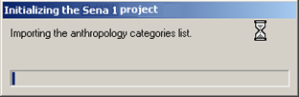
FieldWorks adds the list of anthropology categories to the Sena 1 project.

A Sena 1 Language Explorer window appears.
At this point, you have two projects open: Sena 3 and your new Sena 1.
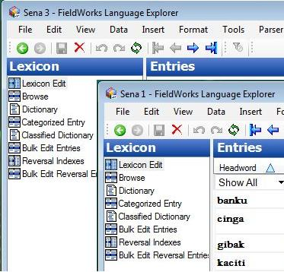

      - The program allows you to work with more than one open project. So at this point, you have two options: you may close the project called Sena 3 or leave both open. For the purpose of this course, close Sena 3 by clicking the Close button on the title bar with the name Sena 3.

      - If you happened to close Sena 1 by mistake in the prior step, go to the next page for instructions on how to reopen Sena 1. If Sena 1 is open, maximize its window (), and then continue in Module ED - Entering Data.
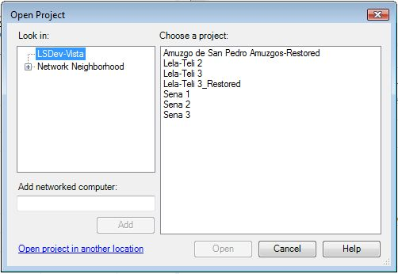
      - To reopen Sena 1: On the File menu, click Open. The Open Project dialog box appears.
      - Select the project you want to open by clicking it (Sena 1 in this example).
      - Click Open.

Course note: We suggest at this point that you maximize () the Sena 1 Language Explorer window.

Module ED: Entering Data
Entering language data into a FieldWorks project is easy. You do not have to know much about a language at all to start recording information in Language Explorer. As your knowledge of the language grows, your FieldWorks database can grow with you in both breadth and depth.

Creating a New Lexical Entry – a simple example
If you have your newly created Sena 1 project open in Language Explorer, you will see that there are no records in the database yet. As you will learn in this topic, creating records (lexical entries) in Language Explorer is very easy. You can create them without knowing "everything" about the entry.

Steps to create a new Lexical Entry
To illustrate how easy it is to create new entries, follow the steps below
- If necessary, open the Sena 1 project. Then in the Navigation Pane, click Lexicon and then click Lexicon Edit.
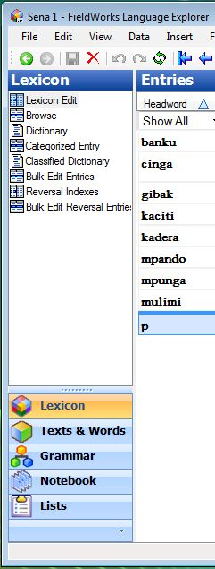
      - On the toolbar, click (Create a new lexical entry icon) with your mouse.
(Alternatively, you can use the keyboard shortcut, Ctrl+E.)

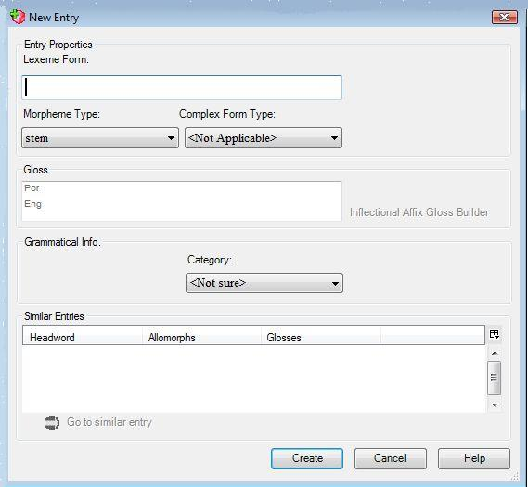
The New Entry dialog box
appears.

      - In the Lexeme Form field,
type myfirstlexeme.

      - Click the Create button at the bottom of the dialog box.
(Alternatively, press the Enter on the keyboard.)

      - The new entry, myfirstlexeme, appears in the Entries pane (center of the screen) and in the Entry pane (the side right of the screen).

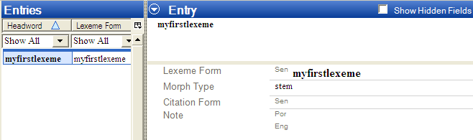

This lexeme is now in your database. It is as simple as that.
Of course, this entry not something we want in the Sena 1 project. So, let's delete it.

Steps to delete a Lexical Entry
      - Using the mouse, click the Delete icon on the toolbar.
(Alternatively, press Ctrl+Del on the keyboard.)
The Delete Entry dialog box appears. Language Explorer presents you with a caution statement letting you know exactly what will be deleted when you click the Delete button. In this case, it should say that myfirstlexeme will be deleted. This is what we want.
      - Using the mouse, click the Delete button at the bottom of the dialog box.
(Alternatively, press the Tab key until the Delete button is highlighted, then press Enter.)
The lexeme, myfirstlexeme, is deleted and no longer appears in the Entries or Entry panes.

Creating a New Lexical Entry – a realistic example
During his first week among the Sena people, Mark was invited to participate in transporting rice during the rice harvest. Listening to conversations, he began to learn some words and phrases. Mark wrote these down on a small pocket sized notebook to enter in his database later.
That evening at home, Mark recorded the information from his notebook (and from memory) into his FieldWorks project.
One of the words Mark learned was a term for farmer.

Steps to create a new entry using the mouse
- If necessary, open the Sena 1 project. Make sure you are in the Lexicon by clicking the Lexicon button in the Navigation Pane. Also, make sure you are in Lexicon Edit by clicking the Lexicon Edit icon under Lexicon at the top of the Navigation Pane.
      - Click on the toolbar, or on the Insert menu, click Entry.
The New Entry dialog box appears.
      - In the Lexeme Form box, type mulimi.
      - At this point, Mark was not sure whether this word is a root or a stem. However, Language Explorer does not require that he know this initially. So for now, he left the Morpheme Type as the default, a stem.
Course Note: If you like, you can click the down arrow in the Morpheme Type box to see the list of choices available.
Language Explorer is aware of most morpheme types that occur in languages.
      - Mark thought this word is a noun in Sena, so he selected noun in the Category box.
With the mouse, click the down arrow in the Category box in the Category Info. area. In the list, click the noun. Alternatively, use the Tab key to move the insertion point into the Category box, and then type an n. If necessary, use the down arrow key to move to Noun (if there are other categories, such as negator that appear before it). Press Enter.
Course Note: Mark could just as well have left the Category field <Not Sure> if he really could not tell at this point. For example, from Mark’s limited understanding, mulimi might be a noun, or it might be a verb. Only further analysis will reveal this. Whatever Mark chooses to do here, he can easily edit this field later when he finds out for sure.
Notice in the Gloss box there is a line for both a Portuguese gloss (Por) and for an English gloss (Eng). This is because we set both Portuguese and English as Analysis Writing Systems for the Sena 1 project.
      - In the Por gloss line, type lavrador. Then, click the Eng line and type farmer.
      - Click the Create button.
Mulimi is now a lexeme in Mark’s Sena 1 database.

Steps to create a new entry using the menu and keyboard
Mark also learned a term for rice. He entered it into his lexical database using the keyboard rather than the mouse.
- If necessary, open the Sena 1 project. Make sure you are in the Lexicon area by clicking the Lexicon button in the Navigation Pane. Also, make sure you are in the Lexicon Edit tool by clicking Lexicon Edit at the top of the Navigation Pane.
      - Press Alt+I and E (underlined letters feature for menus), or press Ctrl+E (shortcut keys feature).
The New Entry dialog box appears. The pointer should already be in the Lexeme Form box.
      - In the Lexeme Form box, type mpunga.
      - Press the Tab key.
The contents of the Morpheme Type field are highlighted, and contains stem. If we wanted to change the morpheme type, we could type the first character of the morpheme type we wanted until it appears in the Morpheme Type field. However, for this entry, stem is the correct morpheme type.
If you wish to experiment, go ahead and type r. The Morpheme Type, root will appear in the box. Type the hyphen character ‘-‘ repeatedly and notice what appears in the box each time. Different types of affix will appear from the list of Morpheme Types. When you are finished experimenting, type s. This will bring stem back into the box, which is what we want for now.
      - Press the Tab key to select (highlight) the contents of the Category Info. pane's Category box.
      - Type N.
The Category chooser list drops down with N highlighted. We will keep this choice for noun.
      - Press Enter to confirm this choice
      - Press the Tab key until the cursor moves to the Gloss box, next to Por. (the abbreviation for Portuguese.)
      - Type the Portuguese gloss arroz.
      - Press the down arrow key.
The cursor moves to Eng.
      - Type the English gloss, rice.
      - Press Enter again to create the entry.
The New Entry dialog box closes and the new entry mpunga appears in the Entries and the Entry panes.
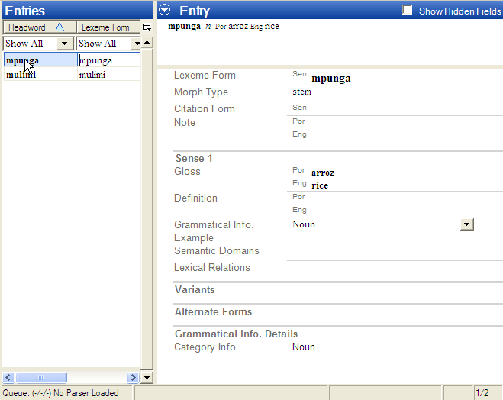

Adding New Senses
So far, we have simply added two lexemes to the Sena 1 database. Notice in the Entry pane that for the lexemes we have entered the Gloss and Grammatical Info. field information is under Sense 1. You can easily add more senses to entries in Language Explorer. In this section, we will create another lexical entry and add a second sense.

Add the new entry
One day, Mark was at the outdoor market when he saw a man having his hair cut. Then Mark learned the verb for that action.
If necessary, open the Sena 1 project. Make sure you are in the Lexicon area by clicking the Lexicon button in the Navigation Pane. Also, make sure you are in the Lexicon Edit tool by clicking Lexicon Edit at the top of the Navigation Pane.
      - In the New Entry dialog box (Ctrl+E), do the following:
- Enter the lexeme form cinga.
- Select stem for the Morpheme Type.
- Enter the Portuguese gloss cortar cabelho and the English gloss cut hair.
- Type V in the Category field and select verb as the category.
- Click the Create button.
The resulting lexical entry should show up under Entries and Entry, as did mpunga and mulimi in previous exercises.

Discover a new sense
Several weeks later, Mark learned the word for shaving one’s beard. It also happens to be cinga. However, at the time he did not make the connection with the verb for cutting hair. Later that day he started to enter this “new” word into his database the way he has done with all his new entries.
- If necessary, open the Sena 1 project. Then, in the Navigation Pane, click Lexicon and then click Lexicon Edit.
      - Open the New Entry dialog box (Ctrl+E).
      - In the Lexeme Form box, begin typing cinga.
Notice that even before you finish typing, cinga appears in the Similar Entries pane near the bottom of the New Entry dialog box.
As he was typing in the Lexeme Form field, Mark noticed that cinga is already in his database and that the gloss is cortat cabelho (cut hair). He decided that what he discovered was not a new word after all, but a new sense of a word he had already recorded. Mark brought up the lexeme, cinga, using the Go to similar entry link. He then added a new sense to it.
Obviously, with only three entries in Sena 1 so far, it is easy for us to see directly that cinga is already in the database. However, imagine if we actually had several hundred entries by now. Having Language Explorer display Similar Entries is very helpful in discovering whether your “new” entry is actually another sense of a current entry, or perhaps even a homonym.
      - Select cinga in the Similar Entries field by either clicking it with the mouse or pressing the Tab key several times until cinga is highlighted.
      - Click the Go to similar entry link at the bottom of the Similar Entries pane.
Language Explorer will take you to the entry, cinga, which is now be highlighted in the Entries pane and displayed in the Entry pane.

Add the new sense
      - With the entry, cinga, displayed in the Entry pane, click the Sense 1 label.
Notice a menu button appears to the left of Sense 1 label.
      - Click the menu button.
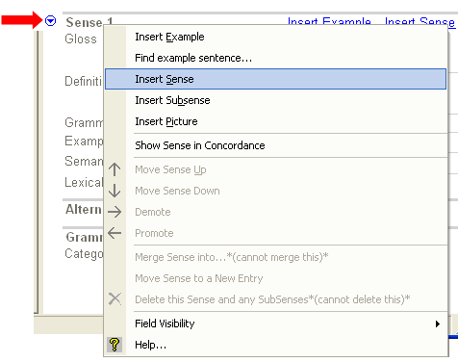
A menu appears.
      - On the menu, click Insert Sense.
A new sense, Sense 2, appears just below Sense 1 in the open window.

      - In the Gloss field, click the Por (for Portuguese) line, and then type barbear.
      - Press the down arrow key on your keyboard to move to the Eng (for English) line, and then type shave.
      - The Grammatical Info box should already show Verb. (If not, click the down arrow in the Grammatical Info box, and then select Verb from the list.)
You have just added the new sense.
Actually, it was added to the database in step 3 above. It just did not have any data in it yet. Also, note that Language Explorer records information into the database as you type. There is no need to invoke a “save” command.

Entering Semantically Categorized Lexical Data
After nine months living with the Sena people, Mark has made a number of friends and can speak the language well enough to organize a word-collection workshop. He invited six people who seem well adept at talking about their language. Over the course of a week they listed about 10,000 words, all keyed to a predefined schema of semantic categories. With the help of a typist, Mark entered these words into his Sena database. He used the Categorized Entry tool to do this efficiently.
After having entered several new entries using the New Entry dialog box, you can see how tedious this would be for a list of 10,000 new words! However, if those words are organized according to semantic domains, the Categorized Entry tool makes this an efficient process. (For more information on running a semantically categorized word-collection workshop, go to http://www.sil.org/computing/ddp/. )

Steps for entering words using Categorized Entry
- If necessary, open the Sena 1 project.
      - In the Navigation Pane, click Lexicon and then click the Categorized Entry tool in the list of tools under Lexicon.
The first time you do this an information box pops up. If you do not want to see it again, select the check box that says, “Don’t show this again,” and then press Ok.
The Categorized Entry tool is displayed. The middle pane displays a nested list of semantic domains. The Semantic Domain pane displays questions to help elicit words, which you enter in the Words for <domain> pane.
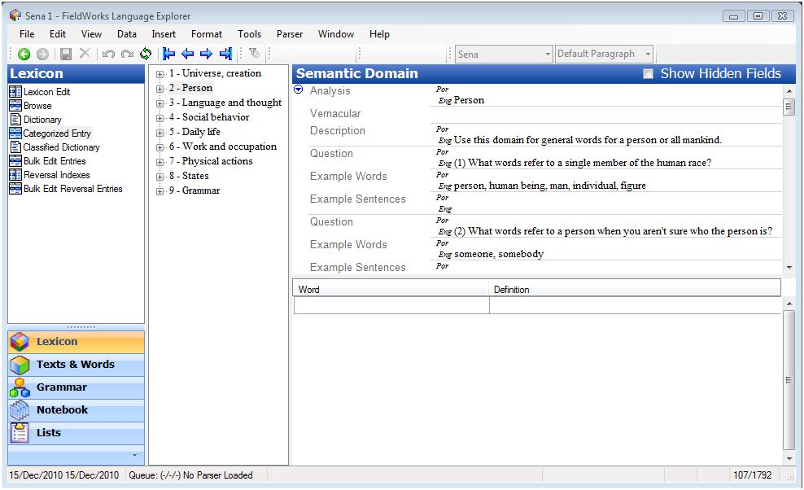

(If the list of semantic domains is obscured by the Semantic Domain pane you can move the leftmost border of the Semantic Domain pane to the right using the mouse. Place the pointer on the leftmost border until the pointer changes to a . Then click and drag the pointer to move the border until you can see the semantic domain list clearly.)
      - Go to the semantic domain for furniture, as follows:
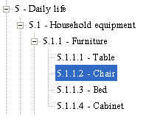
- In the middle pane, expand the outline for 5 -Daily life by clicking the plus sign. Then, expand 5.1 - Household equipment, and 5.1.1 - Furniture.
- Click 5.1.1.2 – Chair to select it.
Notice that the semantic domain for chair is in focus in the Semantic Domain pane.
      - In the lower right pane, click the empty field in the Word column.
      - Type kadera, and then press Tab to move the cursor to the Definition column.
      - In the Definition column, type cadeira, and then press Enter.
(Note that since Portuguese is the primary analysis language, information you type in the definition field will go into the Portuguese definition field in the lexicon.)
You just entered a Sena word and Portuguese definition into your lexical database. A new row is added and the cursor appears in an empty cell in the Word column.
      - Enter the following words and definitions using the Tab or Enter keys to navigate in the columns and rows.
Word | Definition
mpando | banco
kaciti | asento
banku | banco
You should have four words and definitions listed under Words for 5.1.1.2 – Chair.
      - In the Navigation Pane, click Lexicon Edit.
The four words you entered are now lexical entries. Click one of them in the Entries pane, and look at the various fields in the Entry pane.
Notice that the Lexeme Form, Definition (under Sense 1) and Semantic Domain each have content you entered in the Categorized Entry tool. Further, Language Explorer automatically chose the default Morpheme Type, stem and Entry Type, Main Entry.
Lexical entries can be entered very quickly in this manner, but there are basic fields in these entries that need to be filled in. These may also be filled in efficiently using the Bulk Edit tools, as we shall see in another module. (See Editing Data Using Bulk Edit)

Entering Text Data – basic steps
Entering, editing and deleting text data is as easy as typing. In the following exercise, you will create your first texts, edit them and then delete them.

Steps for entering and editing a text for the first time
- If necessary, open the Sena 1 project.
      - In the Navigation Pane, click Texts & Words. Interlinear Texts should be selected at the top of the Navigation Pane, but if not, click it now.
Two empty panes appear on your screen to the right of the Navigation Pane: the Texts pane in the middle and the Text pane on the right. In the Text pane, notice the tabs under the Title box.
      - Click the Baseline tab to open the space where you enter and edit the text.
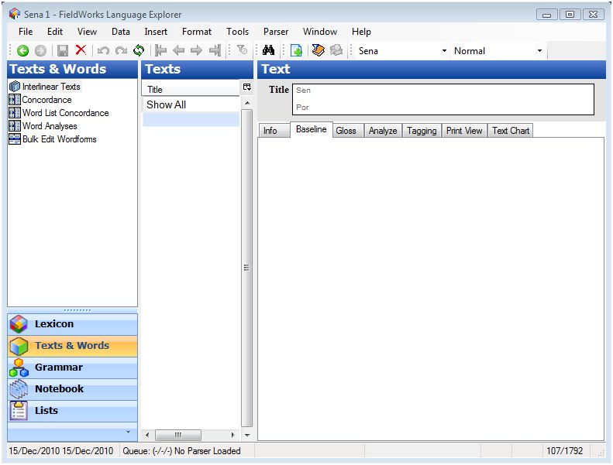
      - Click anywhere in that empty space in the Baseline tab, and then type This is my first text.
(Alternatively, type anything you wish. It does not matter for this exercise.)
You have just entered text data into your Sena 1 database.
Language Explorer saved your text data to the database as you typed it. You can verify this yourself by closing Sena 1, then opening it again, and looking in the Texts area.
Now give your text a name:
      - In the Title box, click the Por (for Portuguese) line, and then type First text.
Your text now has a name. If the title you just typed did not appear in the Texts pane, click the Refresh icon on the toolbar.
(Alternatively, click Refresh on the View menu, or press F5 on the keyboard.)
In Language Explorer, you may have many texts, each one recorded under its own title. The Texts pane contains a list of all your texts, sorted by title. Now you only have one text.
Now edit your text:
      - You can easily edit the text, using cut, copy and paste common to most word processors. For practice, click just after last word in the Baseline tab, and then type that I have entered into Language Explorer.
Note that you can create complications that may cause you some rework if you are not careful with baseline text writing systems. This is discussed in the User Helps.

Add a new text to your text corpus
      - Click on the toolbar to create a new text.
(Alternatively, click New Text on the Insert menu, or press Ctrl+T on the keyboard.)
      - In the Title box, type Second text in the Por line.
      - In the Baseline tab, type This is my second text.
      - If necessary, refresh the screen (F5) to see the titles of both texts in the Texts pane.
Note that the text you see in the Text pane is the one whose title is highlighted in the Texts pane.

Delete a text
      - In the center Texts pane, click First text to bring it into focus.
      - Click the on the toolbar.
(Alternatively, click Delete Record on the Edit menu, or press Ctrl+Del on the keyboard.)
A warning box appears describing what will be deleted if you continue.
      - Click Delete.
First text is deleted and no longer visible in the Texts pane.

Entering Text Data – a realistic example
While learning Sena, Mark recorded a sentence and decided to save it as a text in his database. He also recorded some information about this text in the Comment field on the Info tab.

Steps to add Mark’s text to the Sena 1 database
- If necessary, open the Sena 1 project. In the Navigation Pane, click Texts & Words. Then, click Interlinear Texts.
      - Create a new text by following the steps for Add a new text to your text corpus above.
      - Click the Baseline tab and type (or copy and paste) Pisapha, mbwenye pinafunika n'khuphata ntima. Tonsene njira yathu ndjeneyi.
      - In the Title box, click the Por line, and then type Tenha coragem (which means, "Have courage"). Then, click the Sen line, and type Phatani ntima.
If necessary, refresh the screen (F5) to see the title in the Texts pane.
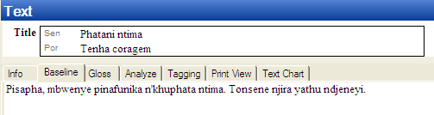

      - In the Text pane, click the Info tab, and then type, "Collected by Mark on 3/5/06 from Tito Anju in Vila de Caia" in the Source field. For this exercise, you can type (or paste) it in either the Por or Eng line.
      - In the Comment field, type or paste "Phatani ntima" ("Have courage") (c) Luís Nyazeze, used by permission. "
As you can see, as far as Language Explorer is concerned, a text can be as short or as long as is useful to your analysis. Normally a text will be a whole discourse unit rather than just a sentence or phrase long. The basic elements of a text record are: the text itself, which is recorded in the Baseline tab; the title and other metadata, which may be written in vernacular and analysis writing systems in the Title field and in the Info tab.
Mark decided to gloss this text by adding word glosses, to the extent of his current knowledge. At this point, he understood what the whole sentence meant, and he knew most of the words. However, he did not know how to parse the words into individual morphemes yet.

Steps to interlinearize a text
Since Mark did not know all the details to break words down into morphemes, he decided to only fill in the word glosses and add a free translation. The simple view is shown in the Gloss tab. It shows the Word Gloss and Word Cat. lines and the Free Translation lines. He will not add the word grammatical categories now.
      - Make sure the text titled Phatani ntima is open in the Text pane by clicking it in the center Texts pane.
      - In the Text pane, click the Gloss tab. The Add Words to Lexicon check box located in the top right corner of the Text pane should be clear (no check mark).
(This feature is useful for monomorphemic languages.)
The text appears with several analysis lines inserted below.
      - On the Tools menu, point to Configure, and then click Interlinear.
- In the Configure Interlinear Lines dialog box, click Free Translation in the Available Lines pane and then click Show>>. A second Free Translation line appears in the Displayed Lines pane. In the Writing System box, select English. Now you will have two sets of Free Translation lines, one for Portuguese and one for English.
- While this dialog box is open, click the Word Gloss line in the Displayed lines pane. Then select English for this line in the Writing System box. For our exercises, we will enter word glosses in English.
- Click OK to close the dialog box.
      - Click the space to the right of the top Free Por label in the Gloss tab. (If needed, special characters can be inserted. On the Insert menu, click Special character. Select the needed character from the chart.) Type in the following Free gloss: “‎Estas coisas doem mas o que é necessario é ter coragem. Pois nós todos vamos morrer.”
Click to the right of the second Free Eng label, and then type, “These things hurt but what is necessary is to have courage.”
In the second line of text, indicated by the 1.2 at the left edge, we only have currently an English free translation, so in the Free Eng line type, "For all of us will die."
Your window should look like this:
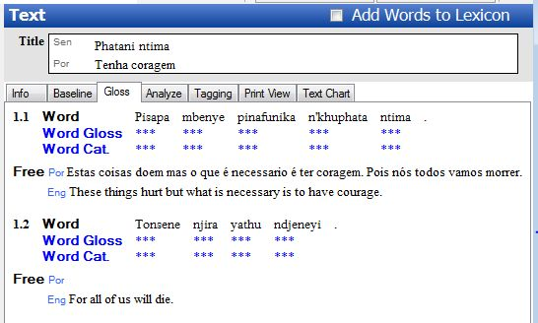

Steps to interlinearize a text – add word glosses
      - Click the word pisapha.
Language Explorer places a box around the word and the associated analysis lines.
For our purposes, we will refer to this box as the "word focus box". Since one interlinearizes text one word at a time, the focus box will only encompass one word at a time. Within the word focus box, fields and controls become available to fill in each analysis line.
      - Click the word focus box and type, "these things hurt". Then, click the green check mark and then click the word focus box for the next word, or press Ctrl+Enter.
      - Repeat steps 1 & 2 for the following words in the text:
Word | Word Gloss
mbwenye | but
pinafunka | what is necessary
n’khuphata | is to hold
ntima | heart
tonsene | all of us
njira | path
yathu | our
ndjeneyi | is really this one
Tip: When you are at the last word in the line, here
ndjeneyi, when you click the green check mark or press Enter, the word focus box does not move as before. However, you can see that the changes were saved by the fact which previously appeared next to the green check mark has disappeared.

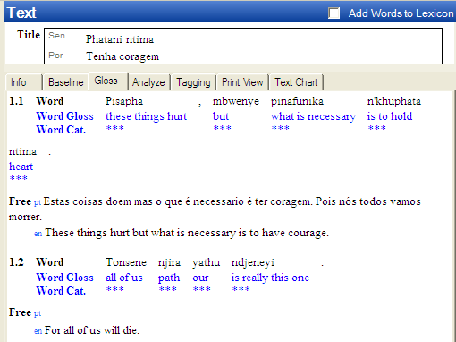

Your Gloss pane should look like the example above.
As you can see, Language Explorer does not require you to know everything before you enter text data. It allows you to fill in information as you learn – at your pace. Of course, all of the information that you enter is editable. Therefore, as your knowledge of a language becomes more refined, your glosses may be fine tuned, and so on.

Steps to interlinearize a text – enter new lexemes to the lexical database
Some time later, after sufficient analysis, Mark found out how to parse a few words from this text into constituent morphemes. He analyzed these wordforms and added the morphemes to his lexical database.
      - In the Text pane, click the Analyze tab.
This view defaults to show the morphological analyses lines as well as those shown in the Gloss tab.
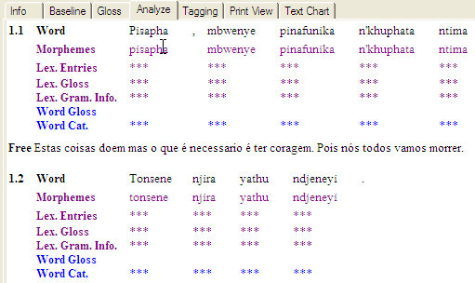

      - We need to configure the interlinear lines for this tab also. On the Tools menu, point to Configure and then click Interlinear.
- In the Configure Interlinear Lines dialog box, select the Word Gloss line in the Displayed lines pane, and then select English in the Writing System box.
- In the Available lines pane, click Free Translation, and then click Show >>. Then, select English for that line in the Writing System box.
- Click OK to close the dialog box.
      - Click the word pisapha and notice the word focus box encompasses the word and its analysis fields. Notice that this looks similar to the word focus box you saw in the Gloss tab, except that there are additional lines shown.
      - Click the down arrow to the left of the Morphemes field, and then select Edit Morph Breaks.
The Insert Morpheme Breaks dialog box appears.
      - In the Word box, insert hyphens and spaces as described in the Break Characters pane in this way: pi- sa- ph –a. Click OK.
Notice that the Morphemes line expanded to show the individual morphemes separately.
      - Click the down arrow to the left of the Lex Entries field for root ph, and then select Create New Entry.
The New Entry dialog box appears. Notice that ph is already in the Lexeme Form line, and stem appears as the default Morpheme Type. Select root in the Morpheme Type box.
      - In the Category Info. area, Category box, select Verb. Then, in the Gloss: box, type the Por gloss fazer doer and the Eng gloss hurt.
      - Click Create.
The word focus box shows the lexeme form of the root ph, the lexeme English gloss hurt and the word gloss.
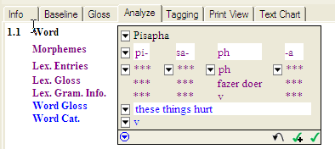
Your word focus box should look like this at this point in the analysis:

The New Entry dialog box that is accessed from the focus box is the same dialog box that appears when in the Lexicon area using Lexicon Edit. When you enter lexical data in the course of interlinearizing text, this data is recorded in your lexical database. To see this for yourself, go to the Lexicon and click Lexicon Edit. Look in the Entries pane and see that the new lexeme <lexeme> appears just as you entered it while interlinearizing text.

Tagging a text
Mark noticed that the possessive adjective yathu comes after the noun that it modifies. He wants to tag these two words as a noun phrase.
      - In the Text pane, click the Tagging tab.
This view is similar to the Analyze view, but does not show a word focus box.
      - As before, we need to configure the interlinear lines for this tab. On the Tools menu, point to Configure, and then click Interlinear.
- In the Configure Interlinear Lines dialog box, select the Word Gloss line in the Displayed lines pane, and then select English in the Writing System box.
- Click OK to close the dialog box.
      - Select the two words njira yathu, then right-click on one of them.
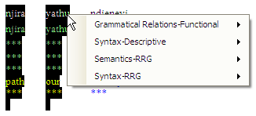
You should see this context-sensitive menu:

      - In the Syntax-Descriptive section, select Noun Phrase.
You will now see a display like this:
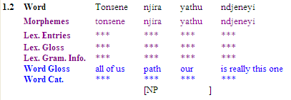
We have finished covering the basics of lexical and text data. You can learn more by browsing the Help files according to your particular needs. You can access Language Explorer Helps using the Help menu, or using the Start menu: Start_All Programs_FieldWorks_Language Explorer_Language Explorer Help.

For more practice
In Excercises, go to Module ED.

Module DC: Discourse Chart (Text Chart tab)
After analyzing the text, you can insert the words in that text into a discourse chart or text chart using the Text Chart tab.
The chart has rows and columns. Each row is a clause. Columns are arranged as pre-nuclear, nuclear and post-nuclear groups, where the nuclear group contains the subject, verb and object/complement. If the sentence structure of the vernacular language you are working with is different, that is not SVO, the columns may be reordered. However, we will not do this in this exercise. (Refer to the User Helps for more information).
When the chart has content, the left column displays numbers that identify sentences and paragraphs, and letters that identify clauses within each sentence. Different line weights are used for the horizontal lines to indicate the end of clauses (lightest), sentences (mid-weight), and paragraphs (heaviest). The right column is an editable Notes field.

Practice inserting text into the chart
- If necessary, open the Sena 1 project. In the Navigation Pane, click Texts & Words. Then, click Interlinear Texts. Then, click the Text Chart tab.
Notice that vernacular interlinearized words from the selected text appear near the bottom of this tab. Below the vernacular word is the word gloss, if you had entered or selected one.
The first vernacular word is always selected and ready for insertion into the chart. When it is appropriate, you can select additional subsequent words.
Notice too, that each column (Outer, Inner, Subject and so on) in the Text Chart tab has a pair of buttons located at the bottom of the column. The larger button has the column name and an up arrow () and its associated button has only down arrow (). You click the button with the up arrow to simply insert the selected word into that column. You click the button with a down arrow to access other options for inserting the word into the chart.
To see the results of the various options, do each of the following and notice the results (do not concern yourself at this time with being correct regarding which columns you insert the various words):
- Click the button with an up arrow () at the bottom of the column into which you want to insert the selected word to put it in the currently lowest row.
- Click the button with a down-arrow () and then select Insert into new Row to insert the selected word into a new row, which is a new clause.
- Click the button with a down-arrow (), point to Insert as Moved from, and then select the desired column. This inserts the words into the chart in an order other than their default word order. The word(s) appear in the column you selected, and a preposed from or postposed from marker appears in the default column.
After you have tried each of the insertion options, let’s review the menu commands that appear when you click a word in the chart. First, make sure that you have words in a number of rows (clauses) and at least one word in each column. Insert words as necessary, but do not concern yourself with being correct.
You should see numbers and letters in the left column (such as 1a, 1b, 2 and so on). If not insert more words into the chart with each of the options listed above.

Practice with Text Chart menu commands
A context-sensitive menu appears when you click any word in the chart. Some of the menu commands have context-sensitive cascading menus. We will not practice with every possible command and cascading menu option, but will instead experiment with enough of them to help you learn the various ways you use them. Do not be concerned with being correct, but instead be observant to notice the effects of using the various commands.
Let’s begin by marking rows as the last row in the sentence and last row in the paragraph.
      - Click (or right click) any word that is in the chart and notice the menu that appears.
Note: When the cursor is located over a word, a menu button appears. To see the menu, you can do any of the following: click the menu button, click the word again, or right-click the word. Any of these bring up a menu with the same commands.
      - Click the Last Row in Sentence command in the menu.
- Notice that the weight of the horizontal line changed and that the numbers and letters in the left column changed.
- Double click the same word again and notice that the Last Row in Sentence command has a check mark. Click any other row to clear the menu from the screen.
      - Click another word in a different clause (row) and then, click the Last Row in Paragraph command in the menu.
- Notice that the weight of the horizontal line changed to an even heavier weight, and that the numbers and letters in the left column changed.
- Double click the same word again and notice that the Last Row in Paragraph and the Last Row in Sentence commands each has a check mark.
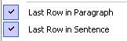
You can click a menu command that has a check mark to clear that check mark from the menu. Clearing a check mark removes the effects of that command.
- Right click (or double click) the last word that you clicked, and then click the Last Row in Paragraph command to clear the check mark from that command.
- Notice that the line weight changed to indicate that the clause is now only the last row in the sentence.
Next, let’s practice with marking a word as preposed. (You mark words as postposed the same in a similar way.)
      - Click any word in the text chart, and then hold your mouse pointer over the Mark as Preposed from command and then over the Mark as Postposed from command.
- Notice the various options in the two different cascading menus that appears. These are the available columns.
The Mark as Preposed from command displays the column labels that appear before the current word, and the Mark as Postposed from command displays the column labels that appear after the current word.
- Now click different words in different columns and again observe the available commands on the menu and the options on the cascading menus change depending on where in the chart you clicked.
The point here is to notice that both the menu and the cascading menu are context sensitive. If for example you click the first word in the top row, notice that the Mark as Postposed from command is not displayed.
      - Click any word in the pre-nuclear Inner column (appears before the Subject column). Point to the Mark as Preposed from command, and then select Subject on the cascading menu.
- Notice that the word marked as preposed (in the Inner column) became red in color. Also, notice that a pink marker << appeared in the Subject column, which indicates the default position of the preposed word.
- Click the word that is marked as preposed (is red in color). Point to the Mark as Preposed from command, and notice that the Subject option on the cascading menu has a check mark.
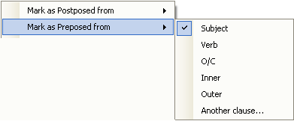
- Click Subject again to remove the check mark and the various markings from the chart.
Next, let’s practice the steps for making dependant clauses. (You make song clauses and speech clauses in a similar way. Different colors appear to indicate the type of clause.)
      - Click any word in the text chart, and then hold your mouse pointer over the Make a Dependant Clause out of the command. Notice the options in the cascading menu that appears.
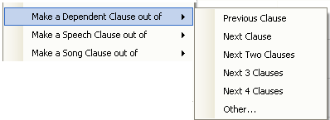
Note: If you had double clicked a word in the first clause, then Previous Clause would not appear as an option in the cascading menu. Similarly, if you had double clicked a word in the last clause, then Next Clause would not appear in the cascading menu.
      - In the cascading menu, click Next Clause.
- Notice that the next or previous clause turned blue in color and is now between square brackets [ ].
- Notice too, that a clause marker appears in the cell with the word you Clicked. The clause markers are blue as well, and indicate the sentence number and clause letter on which the word is dependant. The clause marker, could appear as this example [2a], indicating that word is dependant on the first clause (the “a”) in the second sentence (the “2”).
      - Click the word that has the clause marker. Examine the commands in the menu.
- Notice that the Make a Dependant Clause out of the command has been replaced with a Remove Clause Marker command.
- Click the Remove Clause Marker command. Notice that the clause marker, the blue colors and square brackets are removed from the chart.
The Make a Song Clause out of and Make a Speech Clause out of menu commands function in the same way. You can experiment with them if you want, noticing that the colors are different.
Next, let’s practice with the menu commands Move Word and Move Cell. First, a brief overview:
- Each of these menu commands has a context-sensitive cascading menu with Forward and Back, unless the word is already at the very end or beginning of the chart.
- Move Word moves one word to an adjacent cell, either forward or backwards.
FieldWorks preserves the word order. If, for example, you click a cell with two words and select Move Word…Forward, only the last word in the cell will move. If you select Move Word…Back, only the first word will move from the cell. Correspondingly, if you move a word into a cell that already has a word, the word order is preserved in that cell.
- Move Cell moves the entire content of a cell (one or more words) to an adjacent cell, either forward or backward. The word order is preserved.
If you move a word or cell forward from the last column in the clause, the word or cell contents move down to the next clause. If you move a word or cell back from the first column in the clause, the word or cell contents move up to the next clause.
Neither of these two menu commands change the color of the moved words or add any markers. The words just simply move.
To experiment with these commands, do the following:
      - Click any word in the chart, point to Move Word, and then select Forward.
- You can move the same word more than one time.
The first time you select Move Word…Forward on the menu, that command is remembered, so you can use Ctrl+Right Arrow on the keyboard to make subsequent moves for that word. Similarly, for subsequent Move Word…Back, you can use Ctrl+Left Arrow on the keyboard.
- When a word is at the end of the current row (that is, it is in the last column of the current clause), it will move forward to the next row, unless at the end of the chart.
      - Use Move Word…Forward with various words until you have two or more cells that contain multiple words. Then, do the following:
- Click one of the cells with more than one word, then select Move Word…Forward.
Notice that to preserve the word order only the last word in the cell moves to the adjacent cell. If that adjacent cell already had content, then the moved word appears as the first word in that cell.
      - Right-click a cell that has more than one word, and then select Move Cell….Forward.
Notice that the entire contents of the cell moved, not just one word. Notice too, that the words were moved to the front of receiving cell to preserve word order.
Next, let’s consider the menu commands Mark TenseAspectMood, Mark Pronouns and Mark Demonstratives.
These menu commands and their cascading menus can be extensive, as shown in the example below:
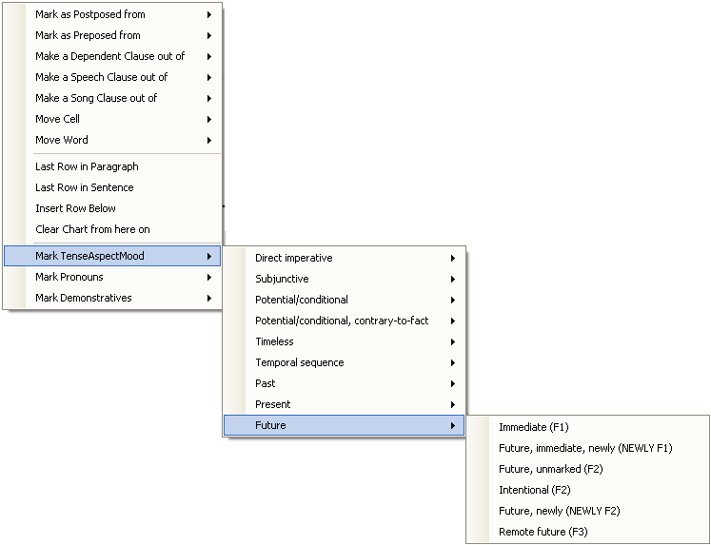

All of these chart markers are stored in the Language Explorer Lists area and are user-editable.
- To mark a word with any of these, do the following:
- Click (or right- click) a cell, point to the desired menu command(s) to display the cascading menu. Then, click the desired marking.
Notice that the abbreviation of the marker, appears in the cell. For example, if you selected Mark TenseAspectMood…Future…Immediate, then (F1) appears in the cell. Also, in the cascading menu, a check mark is added to marker, such as in this example:
- To remove a marker from the cell, Click (or right- click) the cell that has the marker you want to remove. Then navigate to the cascading menu where that option is selected, and then click it again to remove the check mark. This removes the marking from the chart.
Module PM: Project Management

Backing up a FieldWorks project
Mark knows that protecting his data from computer failure or file corruption is critical. He does this by backing it up regularly. FieldWorks offers several ways to manage regular backups. You can configure it to automatically back up your project according to a set schedule. Alternatively, you can have FieldWorks remind you to do this manually yourself. Of course, you do not have to wait for a scheduled time to backup your project. You may manually backup your data at anytime.
When thinking about backup strategies and archiving data, you should consider the following factors:
- It is wise to periodically save your backups to an external medium (for example, CD drive or USB drive). Alternatively, you may choose to backup directly to an external medium.
- Backing up to a folder on your local disk (for example, the Backups subfolder in the My FieldWorks folder) is the fastest way to back up data. However, it will not protect your data from a hard disk crash.
- Your organization may have a repository where you should be sending copies of your backups. (Remember to notify the appropriate person in the organization of your password, if you have password-protected your backups.)

Aside from protecting your data, there are two other uses for making backups:
Porting data to another computer. The actual file that FieldWorks acts on as you enter and edit data is not user-portable. Simply copying a project file or folder to a CD will not work. If you want to put a copy of your project on another computer, the only way to do it is to Backup this Project… to an external medium, and then Restore a Project… on the other computer.
Creating restore points. There may be times in your analysis when you want to test an hypothesis, but you also want to easily get back to your starting point if the hypothesis does not work out. Creating a backup as a restore point can be very useful for this purpose.
Note: Backup this Project and Restore a Project acts on an entire FieldWorks project including data from all FieldWorks applications. For example, if you installed DataNotebook and had anthropology data for the Sena 1 project, backing up Sena 1 from within Language Explorer would also backup Sena 1 anthropology data that was recorded using DataNotebook.

Steps to back up data
      - On the menu bar, click File.
      - Point to Project Management.
      - Click Back up this Project….
The Back up this Project dialog box appears.
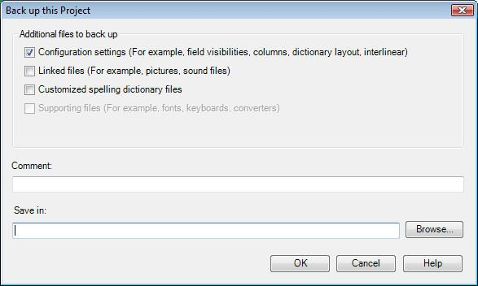
      - Enter any comments about the back up in the Comment field.
      - Click Browse to select the drive and folder where you want the backup to be placed. It is best to choose the default Destination for backups. Keeping the backups in one place will make Restore easier
      - Click OK
Note: To change the frequency of reminders to back up, click Reminders. If you need help in the Backup Reminders dialog box, click Help. To schedule an automatic backup, click Schedule. If you need help in the Backup Schedule dialog box, click Help.

The Backup Progress dialog box appears.
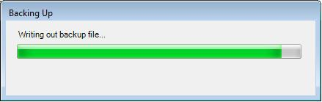

When this dialog box disappears, the backup is finished.

Restoring a FieldWorks project

Steps to restore data
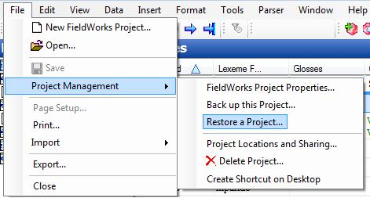
      - On the menu bar, click File.
      - Point to Project Management.

      - Click Restore a Project….
The Restore a Project dialog box appears.
      - Choose Backup location.
      - Choose Name of restored project.
      - Check Additional files to restore if any.
      - Choose Backup version to restore. The Version consists of the FieldWorks project name, date and time of backup (time stamp). If you back up more than once in a day, make sure you select the file with the correct time stamp.
      - Click OK.

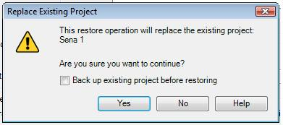
      - The Replace Existing Project dialogue box appears.

      - Click Yes to continue with the restore process.

Note: When you replace the current version of the project, FieldWorks automatically backs the project up to the default backup folder, in case you decide to return to the current version of the project at a later time.

When the project has been restored, Language Explorer opens the restored project.

Module VN: Viewing and Navigating Data
Language Explorer was designed to capture many details about a language’s lexicon, morphology and grammar. As such, there is a lot of information to display. In order to manage what you see at any given time the screen can be customized to meet your needs.

Adjusting Pane Sizes
For any given Language Explorer screen, the panes are divided by splitter bars. These bars are moveable to allow you to see more or less of the contents of a pane. For example, in the Lexicon Edit tool, dragging the pointer to move the splitter bar that separates the Entries pane from the Entry pane to the left will increase the detail view in the Entry pane and decrease the browse view in the Entries pane. In this way, you can allocate screen space according to the task you are working on.

Steps to adjust pane sizes – an example using Lexicon Edit
- Open Sena 1, if it is not already open, and go to the Lexicon area, and click Lexicon Edit. Make sure your Language Explorer window is maximized to use your whole computer screen.
      - Move the mouse pointer over the vertical splitter bar between the Entries pane and the Entry pane. Hover over the splitter bar until you see the pointer changes to .
      - Drag the the pointer to move the splitter bar to the left by holding down the left mouse button while sliding the mouse to the left. Release the mouse button. You should see the relative sizes of the Entries and Entry panes change accordingly.
- Experiment with the other splitter bars in the Lexicon Edit screen. There is another vertical splitter bar between the Navigation Pane and the Entries pane. There is a horizontal splitter bar between the dictionary view and the Lexeme Form field in the Entry pane ().

Note: Although you cannot see it, there is a vertical splitter bar between field labels and field contents in the Entry pane. To find this, move the mouse pointer over a field label such as Citation Form. Then slowly move the pointer to the right until it becomes a . Drag the pointer to move the invisible splitter to the right to see more of the field label. Drag it to the left to see less of the field label and more of the field contents. If you drag this splitter far enough to the left the field labels become abbreviations (Lexeme Form becomes lx, and so on).
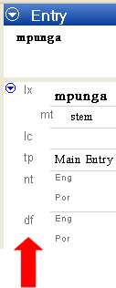

Steps to minimize and restore panes
Some splitter bars offer the ability to jump back to a previous position after having been moved to an outer limit. These are marked with an arrow icon () when they are in an outer limit position.
- In Sena 1, go to the Lexicon area, and then click Lexicon Edit.
Make sure your Language Explorer window is maximized () to use your whole computer screen.
      - Drag the pointer to move the vertical splitter bar that divides the Entries pane and the Entry pane all the way to the far right of the screen. Only the Entries pane will remain visible. The splitter bar will change to show an arrow icon ()at the top of the bar.
      - To restore the Entry pane, do the following: Move the mouse pointer over the splitter bar, anywhere on or below the arrow icon. Click the splitter bar (the arrow icon itself, the word Details below the arrow icon, or anywhere below them) with a single left mouse click. The splitter bar will jump back to its original position before you moved it to the far right. Both the Entries and Entry panes are visible again.
- Repeat the steps above, dragging the splitter to the far left of the Entries pane. Only the Entry pane will be visible. Click the splitter bar to restore the pane configuration as it was before it was moved (or click the arrow icon).
Note: Not all splitter bars have this functionality. In general, only splitter bars that divide between browse and detail views have the ability to jump back to a previous position on the screen.

Customizing What You See in a Pane
Generally speaking, most panes (or views) can be customized to limit or expand how much information you see. This can be very helpful when you want to focus only on certain aspects of your data at a particular time.

Customizing the Navigation Pane
As mentioned in a previous section, you can move the splitter bar to reduce (or increase) the width of the Navigation Pane. You can also choose which area buttons are visible and in which order they appear.
To experiment, open Sena 1. Move the mouse pointer to the button at the bottom right corner of the Navigation Pane. Click on the arrow to open a menu.
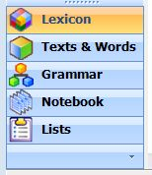

Try different choices from this menu and observe the results.
For more detail on customizing the Navigation Pane, go to Language Explorer Help and view the topic on the Navigation Pane.

Customizing a browse view
In any browse view, for example the Entries in Lexicon Edit, you can choose which columns are visible. You can also adjust the widths of columns, and in most cases you can rearrange their left to right relative order.
- In Sena 1, go to the Lexicon area, and then click Lexicon Edit. Make sure your Language Explorer window is maximized to use your whole computer screen. Drag the pointer to move the vertical splitter bar to the right enough to expand the Entries pane so you can see the effects of the following steps.
      - Click Tools on the menu bar, Configure and then Columns. (You can also open this dialog box by clicking the Configure Columns icon in the top right corner of the Entries pane and choosing More Column Choices from the list.)
To hide a column from the current browse view select the column in the Current Columns pane and click the Remove button. To add a column to the current browse view, select the column in the Column Options pane and click the Add button. To change the relative order in which columns appear, select a column in the Current Columns pane and use the arrow buttons at the right of the pane to move the column up or down in order.
      - Select Glosses in the Column Options pane, and then click Add.
The Glosses column should appear in the Current Columns pane. You may see that there are now two Glosses columns in this pane. We will configure one to show English glosses and the other to show Portuguese glosses. (If you do not see two Glosses columns in the Current Columns pane, add one more using this step.)
      - Select one of the Glosses in the Current Columns pane. Click the down arrow in the Writing System field below this pane, and then select English.
The Glosses column you selected should now show English as the Writing System.
      - Select the other Glosses and configure it for Portuguese in the same manner.
Note that two of the choices for Writing Systems are Default Vernacular and Default Analysis. These defaults are specified in the Writing Systems tab of the Project Properties dialog box. (See Language Explorer Help for more information on configuring Writing Systems.)
      - If Grammatical Info. (Full) does not appear in the Current Columns pane, add it from the Column Options pane.
      - Use the arrow keys at the right of the dialog box to order the columns accordingly: Headword, Lexeme, Grammatical Info. (Full), Glosses(Eng), Glosses(Por).
      - Click OK.
Observe the Entries pane and see that the columns you just configured appear in the order you specified.
Apart from using the Configure Columns dialog box, you can adjust columns directly on your screen. To reorder the columns, drag the pointer and drop the column header labels to the positions you want. To adjust the width of a column, move the mouse pointer to the margin of the column header and drag the pointer to move the margin to the width you want to see.
Tip: The blue triangle () in a column heading indicates that the current sort is on that column.

Customizing a detail view
In any detail view you can configure which fields are visible and which are hidden. There are more fields available for lexical entries than will fit in one computer screen. Therefore, it is helpful to limit which fields are visible in order to avoid tedious scrolling.

Steps for hiding fields
At some point in his analysis, Mark decided to focus on filling in pronunciation fields for his lexical entries. He also wanted to flesh out definitions and provide example sentences. He decided to hide all the fields in the Entry pane except for the ones that were relevant to this task.
- Open the Sena 1 project (Open on the File menu), if it is not already open. Go to the Lexicon, and then click Lexicon Edit. Adjust the splitter bar to show enough of the Entry pane to see the effects of the steps below.
- If the Show Hidden Fields check box on the Entry pane title bar is selected (has a check mark), click the check box to clear it (remove the check mark).
      - In the Entry pane, click the field label Morph Type.
A small arrow icon (referred to as a "menu button") appears to the left of the Morph Type field label. (Tip: You can also use this menu button to see User Helps for the current field.)
      - Click the menu button, point to Field Visibility, and then click Normally Hidden.
The Morph Type field disappears from view.
      - In the same way, hide Summary Definition.
      - Under Sense, hide the Lexical Relations fields.
      - Continue to hide fields until the only ones visible are: Lexeme Form, Morph Type, Citation Form, Gloss, Definition, Grammatical Info, and Example.

Steps for showing hidden fields
The first time you use Language Explorer, the initial visibility setting for many lexical entry fields is Normally hidden, unless non-empty. This is the case for the Pronunciation field. Since Mark wants to focus on filling these in he would like to make these fields Always visible.
      - On the right side of the Entry pane’s Information bar, select the Show Hidden Fields check box. (The check box should have a check mark.)
All the fields that are available for lexical entries in Language Explorer are now shown in the Entry pane.
If you wish, scroll down the pane to see the range of information you can record for any given lexeme. For a description of a given field, right click the field label and select Help…. Some projects will only use a subset of all the available fields.
      - Find the Pronunciation field, which is near the top. Right click Pronunciation, point to Field Visibility, and then select Always visible.
      - Clear the Show Hidden Fields check box.
The view reverts to showing data according to field visibility settings. Notice that Pronunciation now continues to appear, slightly below Citation Form.

Steps for hiding fields unless they contain data
There are many fields that may only be used occasionally, such as the numerous note fields. In such cases, it is nicer to not see the field, unless it has information in it. The field visibility setting to use for this is Normally hidden, unless non-empty.
Though Mark only had phonology and/or grammar notes for half of his entries, he wanted to see these notes while working on pronunciations and definitions.
      - Select Show Hidden Fields to display all the fields.
      - Scroll down to Grammar Note, right click it and configure its visibility to Normally hidden, unless non-empty.
      - Do the same for Phonology Note.
      - In the Grammar Note and Phonology Note fields type this is a test note.
      - Clear the Show Hidden Fields check box.
Notice that the Grammar Note and Phonology Note fields are visible, showing the data you just typed.
Browse other entries and observe that the Grammar Note and Phonology Note fields do not appear when there are no notes to show.
For more information on how to customize the Language Explorer screen, see Language Explorer Help.

Finding Entries
When your database becomes very large, it will become more tedious to scroll the Entries pane to find a particular entry. Language Explorer provides tools to help you move through your data efficiently. The Sena 3 project is larger, so we will open that project (Sena 3) for the steps below.

Moving between entries using the navigation buttons
- Open the Sena 3 project (Click Open on the File menu.). Go to the Lexicon, and then select Lexicon Edit.
Use the navigation buttons on the Standard toolbar. These allow you to go to the first entry, the previous entry, the next entry and the last entry in the database.

First Entry
Previous Entry
Next Entry
Last Entry

      - Click the Next Entry button to go to the next entry in the database.
      - Click the Previous Entry button to go to the previous entry in the database.
      - Click the Last Entry button to go to the final entry.
      - Click the First Entry button to go to the first entry.

Moving to an entry using the Find Lexical Entry dialog box
      - In the Sena 3 database, on the toolbar, click (the Find a lexical entry icon) to open the Find Lexical Entry dialog box.
(Alternatively, you can click Find lexical entry on the Edit menu, or on the keyboard, press, Ctrl+F.)
      - In the Find box, type cik.
Language Explorer will look up entries that begin with cik and display them in the Lexical Entries window of the dialog box.
      - Click cikwa in the Lexical Entries pane, and then click Go To.
Notice that cikwa is now selected in the Entries pane and is displayed in the Entry pane.
Note that there is also an option to create a new entry from the Find Lexical Entry dialog box. You may discover that the entry you are trying to find does not exist in your data yet. If so, click Create instead of Go To. The New Entry dialog box will appear.
Using Find Lexical Entry to enter new lexemes may be a useful strategy to avoid creating duplicates. As you type the entry in the Find field, you may discover you already have the entry in your database. Select the entry, and then click Go To so you can add any additional information you may have.
For more detail on using Find Lexical Entry, consult Language Explorer Help.

Module SF: Sorting and Filtering Data
In order to see patterns in data, it is important to be able to organize and arrange it in different ways. For example, sorting words based on the end of the word can help you discover suffixes.

Sorting Data
In Language Explorer, any browse view can be sorted in multiple ways. To sort by gloss, for example, one simply clicks the Glosses column header in a browse view. The following exercise will illustrate the different ways you can sort data.
- Open the Sena 3 project. Go to the Lexicon, and then click Browse. Using the Configure Columns dialog box, configure the browse view to show the following columns in the following order: Headword, Lexeme Form, Glosses (Eng), Glosses (Por), and Grammatical Info. (Full). (For instruction on configuring columns, see Customizing a browse view in Customizing Views and Navigation.)
Click the Headword column header to sort all entries by headword. The blue triangle () in the column heading indicates that the current alphabetical sort is on that column.
      - When the triangle icon points up, the first entry is displayed at the top of the list.
      - When the triangle icon points down, last entry is displayed at the top of the list.

Note: The alphabetical sort order is a property of the Writing System. The standard Unicode sort order is the default. See Language Explorer Help under the Writing Systems topic to see how to modify the sort order.
      - Click the Headword column header again to reverse the sort order.
Note the direction of the triangle and the order of the entries.
      - Repeat steps 1 and 2 for the Glosses (Eng) column and observe the results.
      - Click on the Lexeme Form column header to sort by lexeme form.
      - Right-click the Lexeme column header, and then select the Sorted From End check box to sort according to the end of the lexeme.
The justification of the content in that column reverses to indicate that the data is now sorted from the trailing end.
      - Click the Lexeme column header and notice that the sort order reverses, however lexemes are still sorted by the end of the lexeme.
      - Right-click the Lexeme column header, and then uncheck the Sorted From End check box by clicking it.
Lexemes will again be sorted alphabetically according to the beginning (leading) characters.
For more information on how sorting affects the display of data, see Language Explorer Help, Basic Tasks \ Sorting Data. Of particular interest is the section on sorting lexical entries.

Filtering Data
Below all column headers are filter menus. Click on the down arrows to select specific filters for that column. These filters allow you to view subsets of your data.
For example, to find lexemes where no gloss is recorded yet you could filter on blank gloss fields. Alternatively, to analyze where a certain morpheme break should occur you can filter on character sequences. The following exercise will illustrate different ways you can filter data.
- Open the Sena 3 project. Go to the Lexicon, and then click Browse. Using the Configure Columns dialog box, configure the browse view to show the following columns in the following order: Headword, Lexeme, Glosses (Eng), Glosses (Por), and Grammatical Info. (Full). (For instruction on configuring columns, see Customizing a browse view in Customizing Views and Navigation.)

Using the preconfigured filters
      - In the Grammatical Info column, click the down arrow just under the column heading.
A list appears with list filter options you can select. (Show All is the default unfiltered view.)
      - In the list, select Blanks.
Only the lexical entries with blank Grammatical Info fields appear on the screen.

Important concepts:
Notice on the status bar in the lower right corner of the screen the word Filtered appears and is highlighted. This indicates that what you see in the browse view is a subset of the database. This is handy in cases where it may not be obvious from the data displayed that a filter is active.
Notice also the current record/total records display in the bottom right corner of the screen. The number before the slash is the order number of the selected entry according to the current primary sort. The number after the slash is the total number of records being displayed in the browse view, again according to the current sort. When a filter is active, you can see how many records match the filter by observing this number. For example, Filtered 3/257 indicates that 257 records match the filter and that the currently selected record is the 3rd record from the top of the list. In steps that follow, take note of how the record number/total records display changes as you apply and remove filters.
You need to understand that in Lexicon Edit or Browse, the current record/total records values depend on the primary sort. If the primary sort column belongs to the entry (such as Lexeme Form), the values are entry counts. If the primary sort column belongs to the senses, (such as Definitions), then the values are sense counts.
In the first case, each row displayed is an entry and the values reflect any filters used. Entries are not displayed more than one time even if more than one sense matches filter criterion.
In the second case, each row displayed is a separate sense whose content matches the filter criterion. So, you may see separate rows for senses from a single entry, if multiple senses match the filter criterion.
Correspondingly, in Bulk Edit Entries, the values reflect entry counts, whereas in Bulk Edit Senses the values reflect sense counts.
      - Click the down arrow under the Grammatical Info column header and select Show All.
All the lexical entries become visible again.
The only preconfigured filters available are Blanks and Non-blanks. Non-blanks will exclude data where the filtered field is empty. In other columns there are other options that you configure. For example, in columns that contain only numerical values there is a Restrict option, and in columns that contain list items there is a Choose option.

Filtering on character sequences
Another option in the filter drop down list is Filter for. Selecting this will open the Filter for items containing dialog box. You can use this feature to filter on character sequences and various other criteria such as case and position in the word.
      - Click the down arrow below the Grammatical Info column heading, and then select Filter for.
The Filter for items containing dialog box appears.
      - In the Enter text to search for box, type Nome. (Nome is the Portuguese equivalent for Noun.)
Leave the option Anywhere selected. Leave Match case and Match diacritics cleared.
      - Click OK.
Now, only the lexemes that are classified as Nome are visible in the browse view.
You can apply filters to more than one column at a time.
      - Under the Headword column, open the Filter for items containing dialog box. (Click the down arrow below the Headword column heading, and then click Filter for.)
      - In the Enter text to search for box, type mb.
      - Select At start to filter for mb at the beginning of words.
Leave Match case and Match diacritics cleared.
      - Click OK.
Now only Headwords that begin with mb, and which are classified as Nome are visible.
When two or more filters are active, it can be tedious to turn them all off one by one by selecting Show All under each filtered column header. To turn off all filters at once there is a control on the toolbar.
      - To turn off all the filters, click the Turn off all filters icon on the toolbar. Alternatively, on the View menu, point to Filters, and then click No Filter. Now all lexical entries are visible in the browse view again.
To learn more about filters, see the topic on filtering data under Basic Tasks in Language Explorer Help. Of particular interest is the use of regular expressions.

For more practice
In Exercises, go to Module SF.

Module BE: Editing Data Using Bulk Edit
In previous modules, we discussed how to enter, edit and delete data on an entry-by-entry basis. In general, one edits the information in entries using a detail view such as the Entry pane in the Lexicon Edit tool. There are some situations however where the same action needs to be taken on many records. It would be handy to select all the records that need the particular edit and then do the action once for all of them simultaneously. The Bulk Edit tools offer this functionality.
A full description of Bulk Edit features is beyond the scope of this manual. We will do a simple Bulk Edit action in this module as an example to introduce the concept.

Using Bulk Edit to copy information from one field to another
After entering many new words into his database using the Categorized Entry tool, Mark would like to populate the Gloss field from the Definition field.
- Open Sena 1 and go to the Lexicon, and then click Bulk Edit Entries. (Note, make sure you have completed the Entering Data module before doing this exercise.)
Note that Bulk Edit operates on a browse view of your data. As such, you can configure columns, sort and filter as you would any browse view. In this way, you can narrow down which data you will act on when you perform a Bulk Edit operation.
      - Filter on the Gloss field to show only blank fields. (See Filtering Data for instructions on how to do this.)
The only entries that appear should be the ones without glosses now.
If we indeed had a large database, we might also filter on Definition for Non-blanks to further narrow down the data we act on. In this example, it is not necessary.
      - Click the Bulk Copy tab at the bottom of the screen.
      - In the Source Field box, select Definition.
      - In the Target Field box, select Glosses.
Bulk Copy is now set up to copy the information in the Definition field to the Gloss field of every check-marked entry in the browse view pane.
To exclude an entry from the Bulk Edit operation, uncheck the check box for that entry.
      - Click Preview to see what will happen if you proceed with the Bulk Copy operation.
The contents of the Definition fields should appear in the Gloss fields with arrows to the left of each gloss. The arrows indicate the change that will happen if you press the Apply button.
It is advisable to press Preview before applying any Bulk Edit operation in order to check and make sure the change is what you want. If the change is not what you want, press the Clear button (the Preview button changes to Clear after you click it) and adjust the Bulk Edit parameters as needed.
      - Click the Apply button to perform the Bulk Copy.

Summary - General process to follow for using Bulk Copy
The bulk edit tools (Bulk Edit Entries, Bulk Edit Reversal Entries and Bulk Edit Wordforms) in Language Explorer offer an efficient way to edit data one field at a time rather than one entry at a time. In general, for any bulk edit operation follow the steps below:
      - Select the bulk edit tool that pertains to the information you want to operate on.
      - Configure the browse view to show the columns you need for filtering and editing data.
      - Apply filters to narrow down the subset of data you want to operate on.
      - Uncheck entries that you want to further exclude from the operation. Depending on the number of rows in the window, you will often use the check box feature to select all rows, clear all rows or to toggle the selected/cleared rows.
      - Choose the bulk edit operation you want to apply (select a tab at the bottom of the screen) and set the parameters of the operation.
      - Preview the changes that will take place if you follow through with the operation. If the changes are not what you want, press the Clear button and adjust the parameters.
      - Press Apply to carry out the operation.
To learn the many other Bulk Edit operations available, see Bulk Edit Senses and Bulk Edit Entries under Lexicon Tools in Language Explorer Help. For more insight in how to use Bulk Edit tools in tandem with rapid dictionary development, see Introduction to Lexicography, which is under Resources in the Help menu.

Module SD: Sharing Data
Making data available to others is an important aspect of any project. Typical reasons people share data:
- To collaborate with fellow coworkers.
- To have a consultant check their work.
- To have a committee review work done on a dictionary.
- To publish information either in print or on the web.
In the following sections, we will discuss sharing database files, printing from Language Explorer and exporting data for use in other software.

Transferring Data to another Computer
The best way to transfer a FieldWorks project from one computer to another is to use Backup and Restore. See Using Project Management for instructions.

Steps to put a copy of a project on another computer
      - Backup the Sena 3 project on the original computer.
      - Save a copy of the backup file on external media.
      - Transfer the backup file to the second computer.
      - Start Language Explorer on the second computer, and then restore the project from the backup file.
(The same version of FieldWorks must be installed on the second computer as was used to create the backup on the first computer.)
You may need to copy other files to the second computer for your project to display properly. Files such as fonts, Keyman keyboards, etc. are not backed up as part of the FieldWorks project. See Files that FieldWorks does not back up under Project Management in Language Explorer Help for full information.
For more information on collaboration, see Collaborating with Others under Basic Tasks overview in Language Explorer Help.

Printing Configured Dictionary Data
One of the projects Mark wanted to do was produce a simple Sena dictionary with Portuguese and English glosses. This would be published for the Sena elementary school system. Mark was working with a dictionary committee and needed to print out a subset of dictionary entries for their review. He used filters to isolate the b section of the dictionary. He then used Dictionary features to configure the dictionary view. Mark wanted the printout to include the Sena headword, the grammatical information, and the Portuguese and English glosses. Once he produced this view in Language Explorer, he printed out hard copies for the committee to use.

Steps to configure and print out dictionary entries
- Open Sena 3 and go to the Lexicon, and then click Lexicon Edit. Filter on entries that begin with the letter b by applying a filter in the Headword column in the Entries pane. (See Filtering Data for instructions.) Only words starting in b should now appear in the Entries pane.
      - In the Navigation Pane, click Dictionary.
Notice that only the b section of the dictionary is visible.
      - On the menu bar, click Tools, point to Configure, and then click Dictionary to open the Configure Dictionary View dialog box.
      - Make sure that Stem-based appears in the Choose dictionary view to configure box.
The Configure pane shows a hierarchical list of items (fields and field groups). Those with a check box are displayed in the dictionary; those with a cleared check box are not displayed.
In the hierarchical list, you can expand any item that has a (plus sign). However, if the check box for that item is cleared, then no item under it will be displayed in the dictionary. Therefore, you do not need to expand every item and clear every check box. For example, if you clear the check box for Pronunciations, then Pronunciation, CV Pattern, and Tone will not appear in the view even if they have check marks.
Correspondingly, if you want to display an item at a lower hierarchical level, then parent item(s) needs to be checked. For example, to display Grammatical Info, Senses must have a check mark.
      - In the Configure pane, under Main Entry clear the check box on each item that we do not want to display in the dictionary view. In this case, we need to have check marks on the following items: Headword, Senses, and Grammatical Info and Gloss (both are under Senses). (Note: The next page has a picture of the dialog box.)
      - Under Senses, expand Grammatical Info to show the items under it (Category Info, Slots and so on). Then make sure each item has a check mark.
      - Also under Sense, select the Gloss, that is select its name like this .
The right pane now has Senses: Gloss at the top, with various boxes and options you can use to configure how Gloss field content will appear.
      - By default, the Display if data present check box has a check mark. Make sure this check box has a check mark in your dialog box.
      - In the Writing Systems pane, make sure Portuguese and English have check marks.
For this exercise, we will not select a character style or add any surrounding content to the display. However, you can return later to experiment with these features.
      - By default, the Display Writing System Abbreviation check box has a check mark. Make sure this check box has a check mark in your dialog box. This will allow Por and Eng to appear next to the glosses to identify the writing systems.
The upper portion of your Configure pane should look like this:
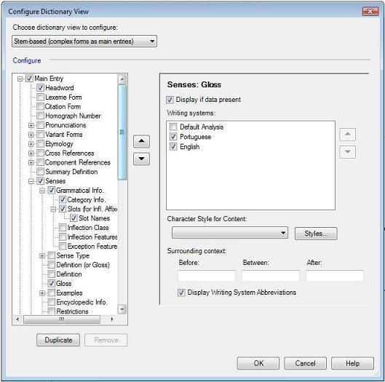
(You can select Inflection Class, Features and Exception Features under Grammatical Info if you want to. It is optional for this exercise.)
      - Next, click (minus sign) to collapse Main Entries, and then click to expand Minor Entry.
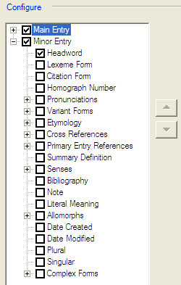
      - Clear the check mark from each top-level check box under Minor Entry, except for Headword.
Your Configure pane should look like this:

      - Click OK at the bottom of the Configure Dictionary dialog box.
The dictionary view now has all the Sena 3 words that start with b, and includes the grammatical category, Portuguese gloss and English gloss for each word. Some entries have more than one sense. For those, you see the sense number appearing with the glosses. For example,
      - On the File menu, click Print to print this section of the dictionary.

Summary for printing dictionary data
      - To print dictionary data you must configure a dictionary view in the Dictionary tool and use File and then Print from the menu bar. .
      - In Lexicon Edit or Browse, use filters to choose the entries that will appear in the Dictionary Entries pane. Sort the entries according to how you want them to print.
      - Open the Dictionary tool. Examine the view to make sure the entries you want to print appear in the order you want them in.
      - Use the Configure Dictionary View dialog box to choose which fields to show and in what order to show them for each entry.
      - When the data is arranged to your satisfaction in the Dictionary Entries pane, use File and then Print from the menu bar to print it out.
The Configure Dictionary View dialog box offers formatting capability to produce good draft output for more complex dictionaries as well. See Configure Dictionary View dialog box in Language Explorer Help for detailed instructions.

Printing text data
Printing text data is similar to printing dictionary data in that first you configure a view of the data and then print that view using the File and then Print from the menu bar. .
- Open Sena 3 and go to the Texts & Words area, click Interlinear Texts, and then click the desired text in the Texts pane. In the Text pane, click the Print View tab in the Text pane.
The selected text will appear in an interlinear format in the Text pane Print View tab.
      - Open the Configure Interlinear Lines dialog box (on the Tools menu, point to Configure, and then click Interlinear).
      - Configure the lines such that the following lines appear in the following order: Word, Word Gloss, and Free Translation. (See Steps to interlinearize a text for sample steps to configure interlinear lines.)
- To see the sufficient data in the print, set Word Gloss and Free Translation to use the English writing system, or optionally, show two Word Gloss and two Free Translation lines, with one set to use Portuguese and the other to use English.
      - Click OK.
The Text pane now displays the text with Word Glosses and Free Translation.
      - On the menu bar click File , and then click Print to print out the text.

Exporting Data
When Mark put the finishing touches on the Sena dictionary for the elementary school system, he needed to have it typeset and published. Since Language Explorer does not provide typesetting capability, he needed to export the data to a format a publishing house could use. He chose to export the dictionary to XML format.

Exporting a configured dictionary to XML
- Configure a dictionary view of the Sena 3 database such that each entry includes the Sena word, the grammatical information and the Portuguese and English glosses. To accomplish this, follow the instructions in Steps to print out dictionary entries with the exception of applying filters. (We want all entries to appear, not just the b section.) Of course, you will not need to print this view, so skip the last step.
      - All Sena 3 entries should appear in the Entries pane in the Dictionary. (Make sure the Dictionary view is selected in the Navigation pane.) On the menu bar click File and then Export.
      - Select the Configured Dictionary XML option, and then click the Export button.
The Export to XML dialog box appears.
      - Choose a folder in the Save in field where you can find the exported file later. If you have a My FieldWorks subfolder in your My Documents folder, this would be a logical choice.
      - In the File name field, type Sena 3 trilingual dictionary, leave the Save as type: XML, and then click Save. The configured dictionary will be exported.
      - Verify that the exported file was created by going to the folder you saved it to and looking for the file. You can right-click the file and select Open with_WordPad to read the file. Someone who knows how to manipulate XML files can transform your data into something that can be typeset for publication.
You can export a configured dictionary to SFM format as well. Follow the same steps above, only select Configured Dictionary SFM option in the Export dialog box. When you open the resulting file in WordPad, you will see your data in SFM format with MDF style backslash codes.

Exporting a lexical database to MDF format
The third option in the Export dialog box (click Export Lexicon on the File menu) is Lexicon MDF Standard Format. One of the best uses of this option is to publish your dictionary on the web using Lexique Pro (discussed in the user Helps).

Exporting interlinear text
You can export interlinear text for use in other documents such as research papers or reports. The general procedure is as follows:
      - Open your project in Language Explorer and go to the Texts & Words area. Make sure your interlinear analysis is as complete as you want it before exporting.
      - Use the Configure Interlinear Lines dialog box (on the menu bar click Tools , point to Configure, and then click Interlinear) to configure the analysis lines you want to appear in the exported text.
      - Open the Export dialog box (click Export Interlinear on the File menu), and then do the following:
        - If you primarily want to display your text in a web browser, select the HTML option.
        - If you will be using your own XSLT transforms to render your text, select the Interlinear XML option.
        - If you want to incorporate interlinear text in an Open Office document, select the Open Office Writer option.
        - If you want to incorporate interlinear text in a Word document, select the Microsoft Word XML option. Note that after exporting you will need to run a macro to adjust things. See the instructions in the dialog box or User Help file.
        - If you want to incorporate interlinear text in an XLingPap document, select the appropriate XLingPap method.
      - Click Export to save the exported file to the folder of your choice.

Module NB: Notebook area

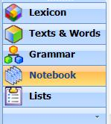
This module is intended to help users get started using the Notebook area in Language Explorer. The Notebook area facilitates cultural research—commonly called ethnography. The goal of ethnography is to describe culture in its own terms. Among the many aspects of culture are patterns of behavior, social organization, community values, the interaction between people and their environment, and demographics.
You can use the Notebook area to learn from fieldnotes for many purposes, including the following:
- To live and work appropriately in a new cultural community
- To help with literacy and educational development by documenting language attitudes, social patterns, and annual cycles of a community
- To help with translation by documenting cultural concepts and terminology
The goal of this training module is for you to be able to enter, categorize, and retrieve cultural data in Notebook. The course does not teach everything you can do in Notebook.
The module does not teach ethnography. It assumes that you are a trained fieldworker or are taking this course as part of a cultural anthropology course.
Appendix AC discusses anthropology categories that are used to categorize lexical entries in Lexicon, and fieldnote records in Notebook. Help is available using the Help menu or using the many context sensitive help buttons in dialog boxes.

About the Notebook area
- In Notebook, the basic unit of information is called a record (to distinguish them from a lexical entry, a text, a list item, and so on). Each record has fields of various types where you record information. Field types include date, text fields, and list reference.
- Date fields store dates, such as the date of event.
- Text fields store your descriptions, discussions, hypothesis, conclusions, and so on.
- List reference fields reference and display items from various lists, which are stored in Language Explorer. Lists allows you to consistently refer to items, such as anthropology categories, so you can categorize records. Other lists store names of individuals, locations, weather conditions, time of data and so on.
- In the Navigation Pane, click Notebook to open the Notebook area. Notice that there are three views or tools; Record Edit, Browse, and Document.
- Record Edit is the tool where you usually insert and edit individual records.
- Browse displays records with the fields shown as columns.
- Document displays records in pages with paragraphs and other literary features to facilitate sequential reading. The entire collection of records is displayed as a single scrolling document, or you can filter to display particular records.
Tip: When Record Edit is displayed, you can click any field to display a blue menu button (). You can click that menu button to see a Help topic which describes the use of that particular field. Hyperlinks in those topics open other topics that provide additional assistance.
- To become familiar with some basic features in the Notebook area, do the following two tasks:
- Entering Notebook data
- Reviewing a lot of fieldnotes

Module ND: Entering Notebook Data
Learning objectives:
- Be able to insert records and subrecords, type descriptions of events, and enter dates of events.
- Be able to insert a custom list and a custom list reference field to use it.
FieldWorks project: To do this module, open the Lela-Teli 1 project.

Scenario A: Writing fieldnote records
After years of preparation, Ruth finally arrives in Tyler on September 13, 2001, where she will be working with the Lela-Teli people.
Almost immediately she wants to record some observations about what she did and saw that first day. Since she wasn’t able to take any notes during the day, she sits down as soon as she possibly can in the evening to write up her first impressions. Since the electricity is off, she uses a bound journal to record her thoughts.
In the morning everyone seems to have disappeared, and the electricity is on. Sensing that her privacy may be short-lived, Ruth starts her computer and inserts her first fieldnote record. She titles it Arriving in Tyler.
Course Note: Information need not be entered in the same sequence as the fields appear in Record Edit.

Insert a record
In general terms, entering your data requires you to insert a new record and put information in the fields of that record. To begin your project, you will enter data using the Record Edit view.
      - Open your Lela-Teli 1 project in Language Explorer. Then, go to the Notebook area. Record Edit should be selected, but if it is not, select it.
      - To insert a record, on the Insert menu, click Record.
The New Record dialog box opens.
      - In the New Record dialog box, do the following:
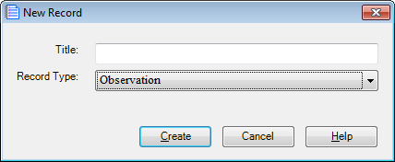
- In the Title box, type the title Arriving In Tyler.
- In the Record Type box, select a record type. For this exercise, select Event.
- Click Create.
(This tile and record type match a record in the Lela-Teli 3 project.)
      - Your Language Explorer window should look like this:
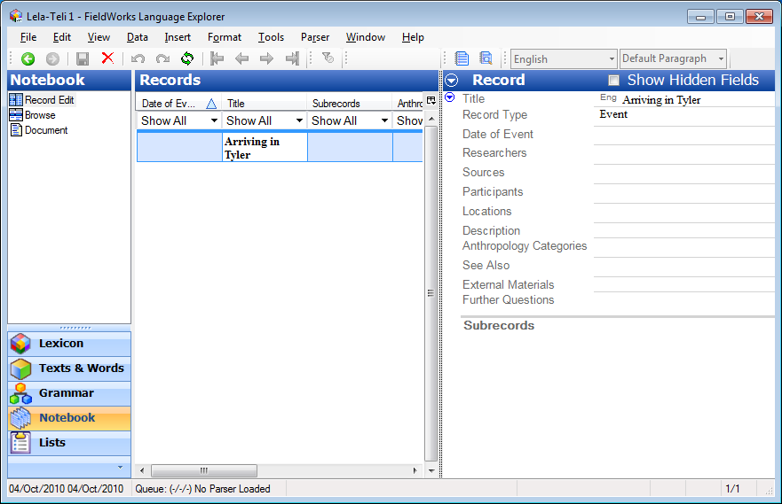

Course Notes: Your work is automatically saved.
Appendix TF describes the use of writing systems in the Title field.

Enter data into a new record
In your new record, you will want to enter data in as many fields as you can. The data entered in the New Record dialog box appears in the Title and Record Type fields. Now, we will enter data in the Date of Event, Description, and Locations fields. This will give you an opportunity to use three different field types. We will do this in the Notebook area, Record Edit view.
      - In your Leli-Teli 1 project, do the following:
      - To enter a date of event, do the following steps:
- Click the Date of Event field, and then click the ellipsis button () that appears.
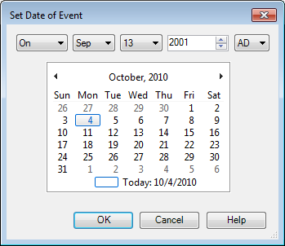
The Set Date of Event dialog box appears.
- In the dialog box, use the various lists to select the precision On, and the date September 13, 2001. (You can also type in the boxes, such as to enter the year.)
Your dialog box should look like this:
- Click OK to insert the date into the field.
      - Normally, to enter data in the Description, you would click in the field and then type. Here, to save typing, do the following:
- Copy the paragraph below (Ctrl+C).
- Click the Description field, and then paste it into the field (Ctrl+V).
Last night we arrived in Tyler. Elsa and I left from Abada at 5 am. It was a very good trip. There are 400 km. of paved roads through to Badaki. From there it was dirt road but still very good. Elsa said it was the best she's ever seen it. They must have worked on it recently and there's not been a lot of rain in the last couple of days. We got to Barsa at 4 p.m. Barsa is a town of about 10,000. The pastor from the DPG that is responsible for the man assigned to the church in Tyler is there. We got to Tyler at a little after five and drove straight to Elsa's house. No one knew we would be arriving today. People began arriving almost immediately to greet Elsa and welcome us. These were primarily from Paul's house next door and Nathan's the other direction plus a lot of children from I don't know where. Paul is the Teli pastor who helps with the translation. Nathan is the Lela pastor under the DPG mission. His wife Julie was delighted to see Elsa. She is expecting. She is Lela also and mostly spoke French to Elsa but apparently is learning Teli as well. The house was locked up and Mark, who lives there, had gone off with the key so everything from the car was moved up on the porch and we then sat down to be greeted. One man on hearing from Elsa that I was staying for a while greeted me in Teli. I stumbled but managed the correct responses which caused great delight.
      - Now, let’s select a location. To select a location, do the following steps:
- In the Record pane, click the Locations field, and then click the ellipsis button () that appears.
The Choose Locations dialog box appears. Notice that it is empty, because the Locations list has no list items.
Let’s add the first location in the Locations list.
- In the Choose Locations dialog box, click the colored link that says Edit the list of Locations.
This opens the Language Explorer window to the Lists area, with the Locations list as the current list.
- On the Insert menu, click Location.
A Locations list item is added, but its fields are empty. Let’s add a location name and a short description.
- In the Location pane, click the line that shows the Lel (Leli-Teli) writing system in the Location Name field, and type Tyler.
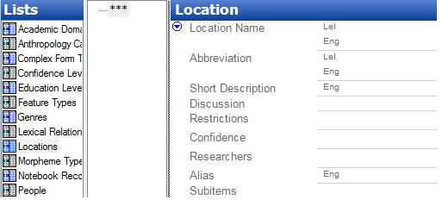

- In the Short Description field, click the line that shows the Eng (English) writing system, and they type This is the first village I lived in.
- On the toolbar, click the green Back arrow () to return to the record in Notebook.
- In the Record pane, click the Locations field again, and then click the ellipsis button () that appears.
The Choose Locations dialog box appears. Notice that now Tyler is an option you can choose.
- In the Choose Locations dialog box, select () the check box next to Tyler, and then click OK.
Your Record pane should look like this:
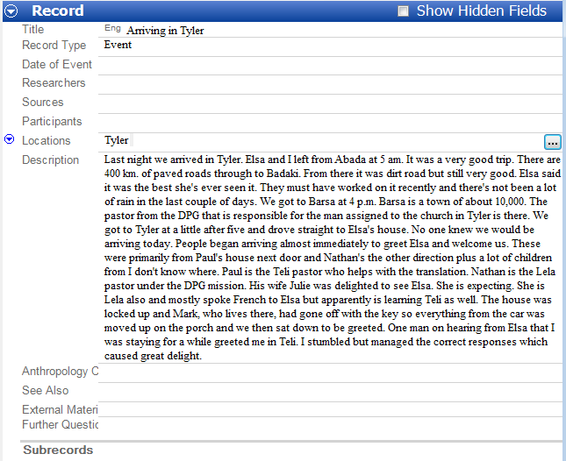

Notice the following in the Record pane:
- To the left of the Locations field label, is a blue menu button (). Click it to see a menu. The menu lists commands you can use for the field.
- One command is Help. Click Help to see a description of the field, with links to related tasks you can do in the field.
- Click any field to see its menu button. You can also right-click a field label or menu button to see the same menu.
- There are fields that you currently cannot see. To see them, select () the Show Hidden Fields check box in the title bar.
- The status bar at the bottom shows 1/1, which means you are viewing the first record, and there is currently one record in the project.
Now you have insert one record in Notebook. You entered a title and selected a record type. Then, you entered data in a text field (Description), and selected a list item for a list reference field (Location). Using other fields are similar.

Scenario B: Breaking a long entry into subrecords
Ruth’s first full day is both exhausting and fascinating. She made the first record in her journal only that morning, but soon she is caught up observing her first funeral. The event covers several groups of people, and takes all day. Although there is too much information to digest, Ruth intends to record as much as she can write after she returns from the funeral. Describing the event is difficult. The funeral theme runs throughout the day’s activities, but there are several distinct sub-events. Ruth would like to keep her observations as a single unit, but makes use of the subrecord feature in Notebook to document the events individually.
Course Note: Subrecords are a feature of in Notebook that allows Ruth to arrange her fieldnotes hierarchically. This is a helpful way to organize a collection of fieldnotes that are all about a single event, like a funeral or a wedding.
Longer records should be divided up into manageable or meaningful ‘chunks’ to later facilitate looking at only those portions of the event dealing with a selected topic. It is not then necessary to read through the entire event to glean the information needed. This will become clearer when we look at categorizing records and subrecords.

Steps to add subrecords
First, let's add the main record called First funeral.
      - In Lela-Teli 1, create a new record titled First funeral as follows:
- On the Insert menu, click Record.
The New Record dialog box appears.
- Click the Title box, and then type First funeral.
The Record Type we want is Observation, and that is the default so you don't need to select it.
- Click Create.
      - Click the Date of Event field, click the ellipsis button, and then set the date to September 14, 2001.
      - Click the Researchers field, and then click the ellipsis button.
The Choose Researchers dialog box opens, but Ruth Schmidt is not yet in the People list, so let's add her.
- Click the Edit the list of People hyperlink, which is near the bottom of the Choose Researchers dialog box.
The Language Explorer window jumps to the Lists area, with the People list selected.
- On the toolbar, click the Insert icon().
- In the Name field, click the line that shows the English writing system (Eng), and then type the name Ruth Schmidt.
- Click the green Back button () two times to return to Notebook.
- Click the Researchers field again, click the ellipsis button, and then select Ruth Schmidt in the Choose Researchers dialog box. Click OK.
      - Click the Description field, and then enter the description that is in the box:
I learned today that the funeral of an elderly woman had begun just outside Tyler. What follows is a description of the first funeral I attended.
When you have finished, it should look like this:
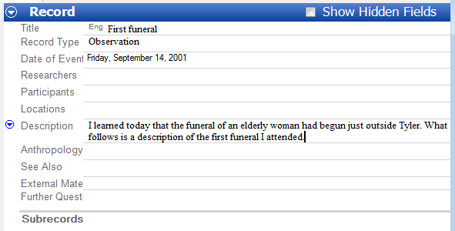
Now, let's insert the first subrecord. Notice the Subrecords field label at the bottom of the record.
      - Click that Subrecords label in your Record pane. Notice a blue menu button () and an Insert Subrecord hyperlink appear, like this:
      - Click in the Insert Subrecord hyperlink.
The New Record dialog box appears again.
      - Click the Title field, and then type Arriving. Leave the Record Type as Observation. Click Create.
      - In the Date of Event field, set the date to September 14, 2001.
      - In the Researcher field, select Ruth Schmidt.
      - Click the Description field, and then enter (you can copy and paste) the description that is in the box:
As it happened at lunch Mark said he was going to the funeral of an old Lela woman who died yesterday so Rachel and I are going with him right after lunch. 1:30 We walked 35 min on beyond Tyler to a place in the bush near the village where the Lela woman died. She died in her village nearby but they move the body out under a tree where more people can collect to cry (and to dance). As we arrive people are eating in various groups. Mark says close relatives bring food for visitors to eat. We can hear singing (crying) over a ways but can't see much.
At this point, your Record pane should look like this:
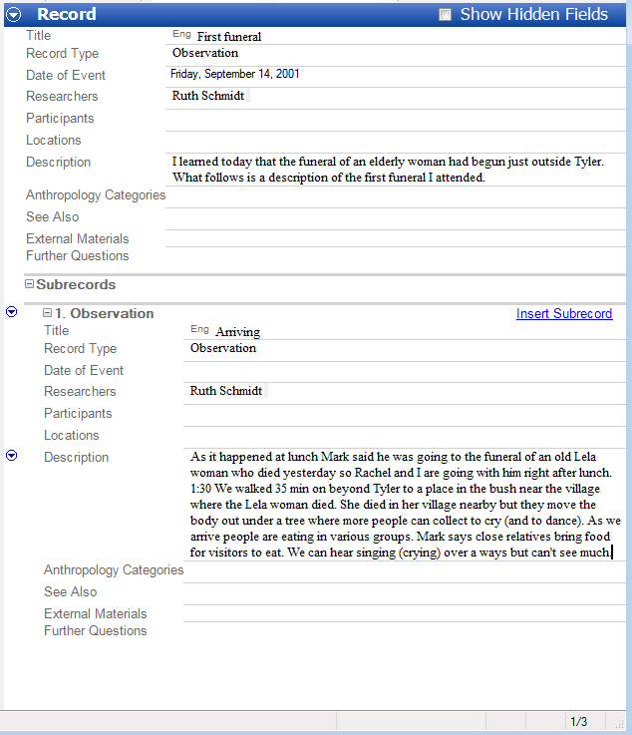

Now let's look at the menu commands that are available on the subrecord heading field.
You can right-click the menu button () or right-click the field label to see the came menu. Let's right-click the Observation label.

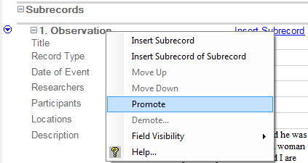

You can
- insert a Subrecord of a Subrecord
- use Move Up and Move Down to reorder subrecords
- use Promote to make a subrecord of subrecords into a subrecord, or a subrecord into a record
- and use Demote to make a subrecord into subrecords of a subrecord. You can also demote a subrecord of a subrecord further down in the hierarchy.
There is another related command, Demote Record. You click the menu button () on the Title bar. You use it to make a record into subrecord.
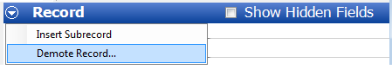

Let's try some of these commands.

Promote, Demote, Move records and subrecords
      - Open Lela-Teli 3, click the Notebook area, and then Record Edit.
      - In the Records pane, click the record First funneral.
      - In the Record pane, scroll to see the second subrecord called First impressions.
      - Right-click that subrecords header (2. Observation), and then click Promote.
      - Notice that now that subrecord has become a record. Look in the Records pane and notice that
- the title, First impressions, is now shown in a bold font in the Title column, and
- First impressions in no longer in the Subrecords column for the First funeral record.
Now, let's demote First impressions to be a subrecord again. Consider that demoting requires you choose a parent record. Let's see how that is done.
      - On the Title bar, click the menu button () on the Title bar, and then click Demote Record.
The Choose Owner of Demoted Record dialog box appears.
      - In the dialog box, click the record Observation - First funeral, and then click OK.
Notice that now First Impressions is now a subrecord under First funeral. More specifically, it is the first subrecord. To move it down, you simply use the Move Down command until the order of the subrecords is as desired.
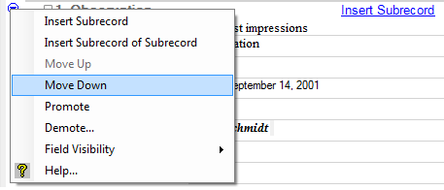

Course Notes: You can experiment with the Move Up and Move Down commands, and watch the order of the subrecords in the Subrecords column and the Subrecord Of column.
In the next scenario, you will filter and short records.

Scenario C: Reviewing a lot of fieldnotes in Notebook

Filter and Sort
Ruth is learning the language and having extended conversations with people. This means she has more information to write up in Notebook. There are now so many records that reading through the events as they are displayed in Record Edit view is not efficient. What she would like to do is scroll through the records, one after the other, and be able to hide extraneous reference fields. Sometimes she would like to focus on the data in the Description field. Other times she needs to examine other specific fields, or browse through titles to find certain records. Ruth decides it is time to learn how to use the different views available to her in Notebook.
For this open the Lela-Teli 3 language project.

Steps in the review process
      - Sort and filter data using the Record Edit or Browse tools.
      - Display the sorted and filtered data using the Document tool.
      - Repeat this process until the desired data is displayed.

Changes in how data is displayed can be made through the Configure Document View dialogue box. Choose Tools from the menu bar, then point to Configure and then click Documents.

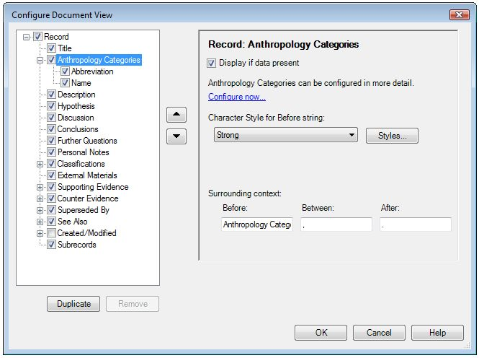

Sort and filter data in Record Edit or Browse
When you sort or filter data in Record Edit or Browse, you also are sorting and filtering the Document view.

Overview: Sorting records
As an overview, you can do one or more of the following to sort your data:
- Click a column header to sort all the displayed data according to the data in that column.
A triangle appears in the header, indicating the primary sort.
- Click the column header again to reverse the sort (ascending versus descending).
The triangle flips to indicate the opposite primary sort direction. Other sort options, described below, are maintained.
- Press Shift and then click a column header of a column other than the one used to set the primary sort order, to provide a secondary sort.
A triangle, smaller that the one that indicates the primary sort, appears indicating the secondary sort. Similarly, a yet smaller triangle indicates a tertiary sort.
- Press Shift and then click a column header of the column that has the secondary sort again to reverse that secondary sort (ascending versus descending).
The smaller triangle flips to indicate the opposite sort direction. Other sort options are maintained.
The triangles look like this: 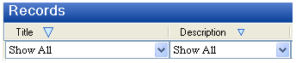
- Right-click a column header that is currently used for the primary or secondary sort, and then select the Sorted From End check box to sort starting at the end of the words rather than from the beginning.
The justification of the content in that column reverses to indicate that the data is now sorted from the end.
- Right-click a column header that is currently used for the primary or secondary sort, and then, if permitted by the column, select Sorted By Length. If desired, you can then click the column header to reverse the sort (ascending versus descending) as described above.
- Right-click the column heading, and then clear the Sorted From End and Sorted By Length check box to sort alphabetically from the beginning of the words.
Overview: Filtering records
As an overview, you can do any of the following to filter your data:
- In the column on which you want to filter data, click the filter arrowjust under a column heading. A list appears with filter options you can select. (Show All normally appears.) The options in the list vary depending on the content of the column.
- In the list, select any of the following as available in the column: Show All, Blanks, Non-blanks, Spelling Errors, Filter for, Yes, No, Choose, Restrict, Greater than 0, Correct, and so on.
One of the following happens:
- The displayed content changes to reflect the current selection.
- The Filter for items containing dialog box appears so you can specify filter criteria, including regular expressions, if desired.
- The Choose Items dialog box appears so you can select items (list items) to filter for and logic options. This dialog box is available if the column is populated by (corresponds to) a list reference field.
- The Restrict to items with (values or dates) dialog box appears so you can select a restriction criterion, and enter a value or a date. This dialog box is available if the column displays a numerical value or date.

Exercise
Now that you have reviewed the overviews (above), let’s set a simple filter in Browse, and then view the results in Document.
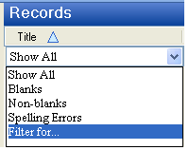
      - Open the Lela-Teli 3 project, if it is not already open.
      - In the Navigation Pane, click Notebook, and then click Browse.
      - In the Title column, click the down arrow, and then click Filter for…
The Filter for items containing dialog box appears.

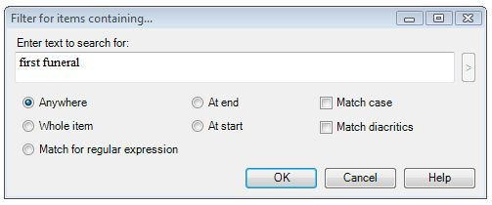
      - In the Filter for items containing dialog box that opens, type First Funeral in the Enter text to search for box.
Your Records pane should show only one record, like this, with only one record displayed.
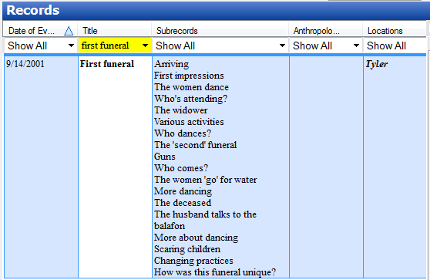

This particular record has 19 subrecords, which you see listed in the Subrecords column.
(In this column, the subrecords are not numbered. To see the numbers, you could configure the columns to display the Subrecord Index column. However, let's not do that at this time.)
- Optional: Click the Subrecords column header, to set the sort on that column. Notice that now each subrecord appears in separate rows. Then, click the Title column header. Notice that now the subrecords are collected again into one row.
      - Click Document in the Navigation pane.
You should see the record First funeral, and a series of subrecords below it, all indented a little to the right. A sample of the Document view is shown on the next page.
With this record and subrecord set displayed, you could print (File menu) the view. You could also specify what is displayed and how it appears using the Configure Document View dialog box. (On the Tools menu, point to Configure, and then click Document.)

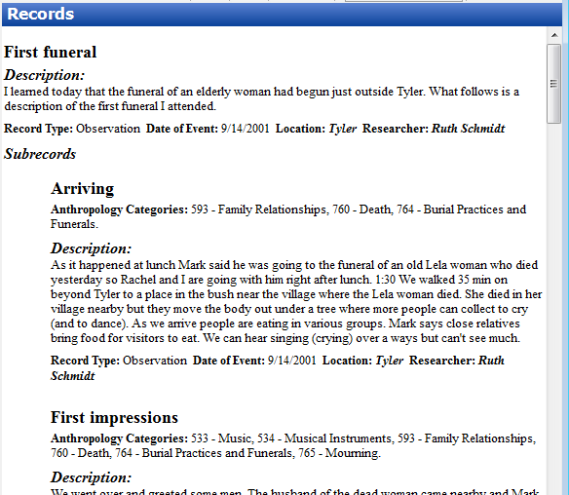

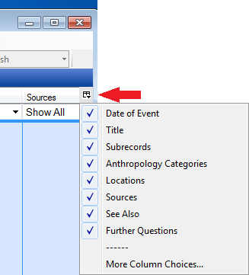
      - Now, let's go back to the Browse view, and configure the columns to see the Subrecords Of and Subrecords Index columns.
- In the Navigation Pane, click Browse.
- At the right end of the column headers, click the configure columns button ().

A list of some of the column you can display appears. More Column Choices opens the Configure Columns dialog box so you can see all the available columns.

- A the bottom of the list, click More Column Choices.
Your Configure Columns dialog box should look similar to this:
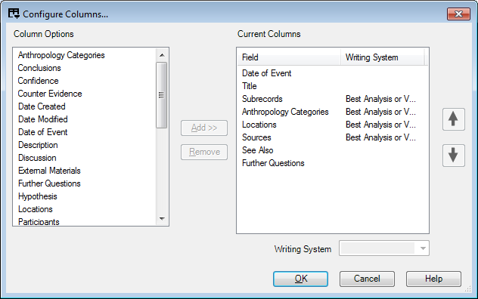

What we want to do now is to remove from view the bottom five columns from the Current Columns pane, and add two columns related to subrecords.
- To remove the unwanted columns, in the Current Columns pane, click the Anthropology Categories column, and then click Remove.
  - Notice, that that column is removed from the Current Columns pane, and that the next column, here Locations, is selected. Because we want to also remove that column, simply click Remove again.
  - Remove the Sources, See Also, and Further Questions in the same way.
- To add the Subrecord Of column, scroll down Column Options pane, until you can see the column.
- Click the Subrecord Of column, and then click Add.

Your Configure Columns pane should look like this:

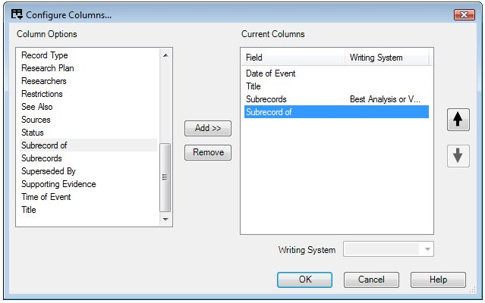

- Click OK to close the Current Columns dialog box.
Your Records pane in Browse should look like this (you can do the same in Record Edit):
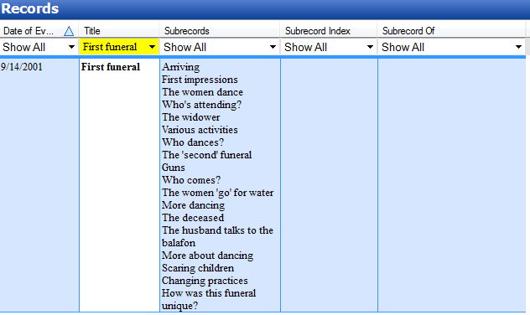
Because the Subrecords column lists all the subrecords associated with the record First funeral, the other columns are empty.
Let's turn off the filter. Then, existing content will appear in the Subrecord Of column. To do that, on the View menu, point to Filters, and then click No Filter.

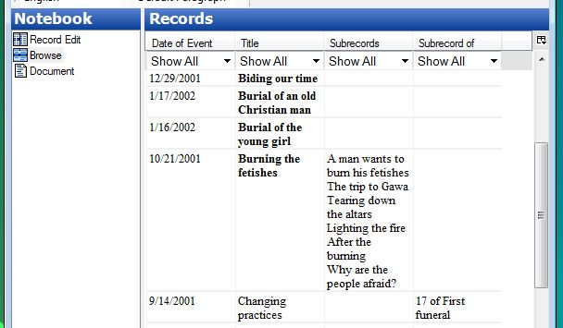

Scenario D: Insert a custom list

Insert a custom list
      - In the Navigation pane, click Lists.
      - On the Insert menu, click Custom List. The New List dialog box appears.
      - In the Name of List field, type in the list name.
      - Under Options, select the check box of your choice.
      - In the Description field, type in a description of the new list. (Refer to the Helps menu for other questions regarding the use of a custom list.)
      - The name of your custom list will appear in the Lists navigation pane.

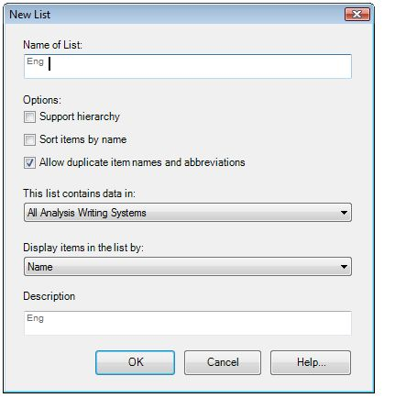

Scenario E: Insert a custom list reference field

Insert a custom list reference field in Lexicon or Notebook
      - In the Navigation Pane choose Lexicon Edit. If a custom field is added in Notebook, choose Record Edit instead.
      - On the Tools menu, point to Configure, and then click Custom Fields.
      - In the Custom Fields dialogue box click Add.
      - Enter or select the information requested in the various dialogue box fields. See the Help file for more detailed instructions.
      - Click OK when you are finished.
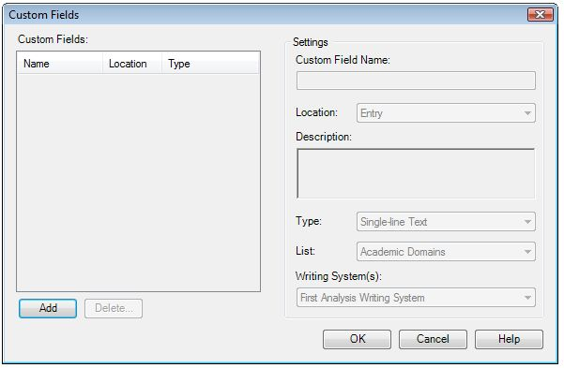

Module DM: Dealing With Multilanguage Data
Learning objective: Be able to identify vernacular text.
FieldWorks project: To do this module, open then Lela-Teli 2 project.
Multilanguage field situations are the norm for most fieldworkers. Often three, four, or more languages are spoken in different contexts among the same people. The fieldworker’s language adds another language to the speech environment.
We assume that data from all languages relevant to the field situation may need to be collected and managed as part of a good research project. Notebook therefore has a design goal to support data in multiple languages and writing systems.
Course Note: Using font attributes to distinguish between Writing Systems: Changing Writing Systems alters the language encoding for text but the differences are not apparent for English, Lela-Teli, and French, all of which are based on a similar Writing System. In order to make a visual distinction between Writing Systems, for Normal style, the font attributes of Lela-Teli are Bold Italic and the font attribute of French is Italic.

Scenario A: Entering vernacular text in a fieldnote
It is important that Ruth switch from the Analysis Writing System— which is based on English—to the Vernacular Writing System when writing Lela-Teli words. Ruth goes through her data and enters words that are in the vernacular after switching the Writing System to Lela-Teli.

Steps to enter Lela-Teli vernacular text
      - Navigate to the entry titled A baby who comes back that was written 17 January 2002.

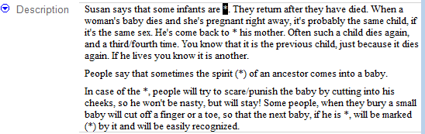

      - Select the first asterisk in the Description field.

      - On the Format menu, point to click Writing System, and then click Lela-Teli.
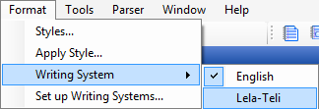

Note that English was initially selected, but when you click Lela-Teli, then the check mark is removed from English and Lela-Teli becomes selected.

      - Type or paste bii dirba.

      - Now, select the next asterisk, and then select Lela-Teli on the format toolbar.
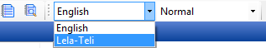
      - Then type or paste this word: falake
      - Continue by selecting each subsequent asterisk, selecting the Lela-Teli Writing System using either the Format menu or toolbar, and then typing or pasting the following words:
tonre keya
dirba
dirba
betike
When you have finished, it should look like this:
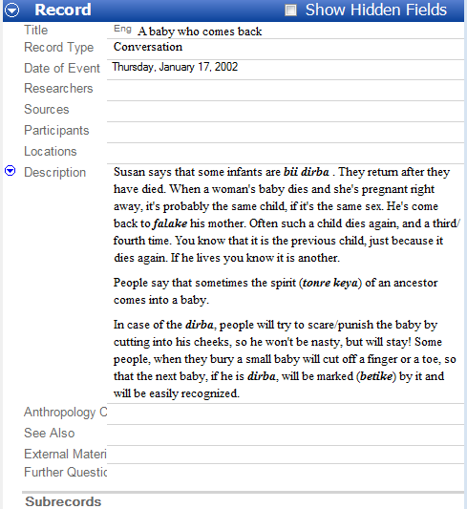

For more practice
In the Exercises go to Module DM and do exercise 1.

Scenario B: Writing a fieldnote in a different language
French is the language of wider communication where Ruth is working. She has many conversations with people in French, instead of Lela-Teli (or English). The following is an entry in French that Ruth adds to her fieldnotes.
Note that the Lela-Teli 2 project is currently configured for only one Analysis Writing System and one Vernacular Writing System (Lela-Teli). Ruth must add French to the Analysis Writing Systems in order to distinguish it from English.
Navigate to the entry titled How the Lela-Teli came to eat maize that was written 14 February 2002.

Steps to add a Writing System
      - On the File menu, point to Project Management, and then click FieldWorks Project Properties.
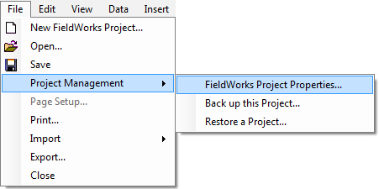

The FieldWorks Project Properties dialog box appears.
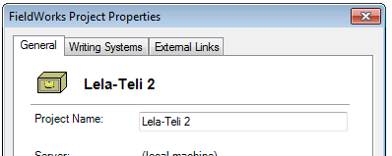

      - Click the Writing Systems tab.
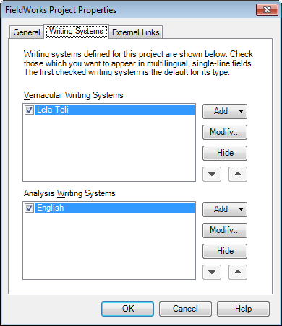

      - To the right of the Analysis Writing Systems list, click Add, and then select French.

Course Notes: French appears in the list, because FieldWorks has already defined it. If you need a language that does not appear in the list, then you probably will need a computer technical support person to create a new writing system for you before you do these steps.

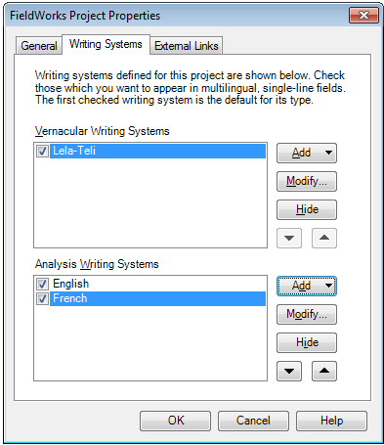

      - Click OK.

Steps to define the font attributes for a Writing System
      - On the Format menu, click Styles.
The Styles dialog box appears.
      - In the Styles list, the Normal style should be selected. But if it isn't, select Normal now.

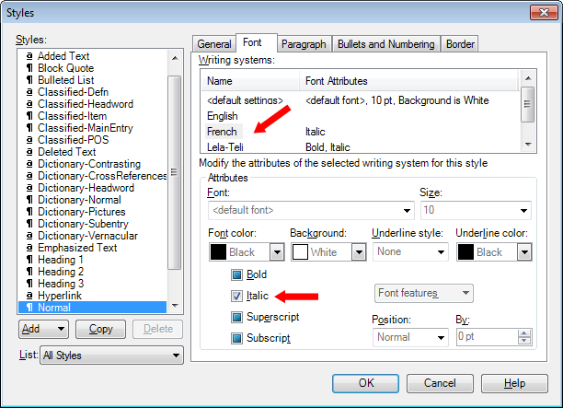

      - Click the Font tab.

      - In the Writing systems list, click French.

      - Select the Italic check box.

You might need to click it more than one time to cycle through the three states these check boxes can have; selected (), cleared (), or inherited ().

      - Click OK.

Steps to write in a different language
      - In the record How the Lela-Teli came to eat maize, in the Description field, click at the end of the sentence, and then press Enter.
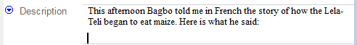
      - On the Format menu, point to Writing System, and then click French.
      - Type or paste the following text.
"Un jour un chasseur est parti à la chasse. Il a rencontré
      - Press Spacebar.
      - On the Format toolbar, select Lela-Teli.
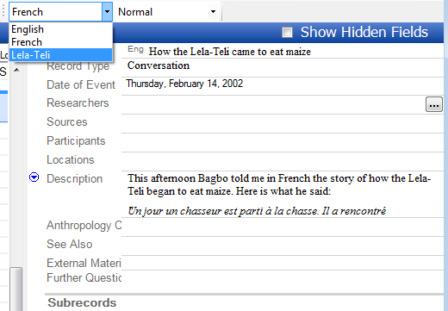
      - Type namba.
      - On the Format toolbar, select French.
      - Press Spacebar.
      - Type or paste the following text.
(singe rouge). Le singe portait du mais. Il disait au chasseur qu'il allait au marché le vendre. Le chasseur voulait en acheter. Quand le singe s'approchait le chasseur le tuait. Il prenait le mais (que le singe avait volé dans le champ de quelqu'un). Le champ a planté.
      - Press Enter.
      - Type or paste the following text.
Avant le mais les Telis mangeaient seulement la terre. Maintenant ils pouvaient manger le mais."
When you have finished it should look like the example:
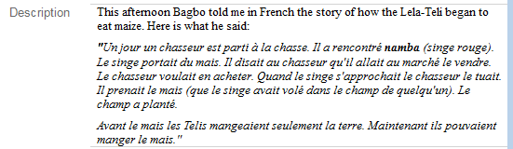

For more practice
In the Exercises go to Module DM and do Exercise 2.

Module AD: Altering Data
Learning objective: Be able to apply character styles to mark text that is added or deleted.
FieldWorks project: To do this module, open the Lela-Teli 2 project.
Generally, any editing of the Description field is discouraged, if it’s been more than a few days since an entry has been written. (Edits to other fields like Anthropology Categories, Further Questions, etc. are expected.) If you really need to make changes, do one of the following:
- To make changes, use styles to mark added and deleted text. Rather than actually delete the text, simply mark it with the Deleted text style.
- To rewrite an entire record: Create a new record, copy the relevant description information into the new record, and edit it there.

Scenario A: Adding data
Ruth wrote an Event Entry on 30 December 2001 titled Surrounding the compound. At the time she wondered who closed the gate. She now knows it is Tiwu the son of Mida. She decides to edit her fieldnote.

Steps to add information to a fieldnote
      - Navigate to the Surrounding the compound record. (You can use Ctrl+F to open the Find Record dialog box.)
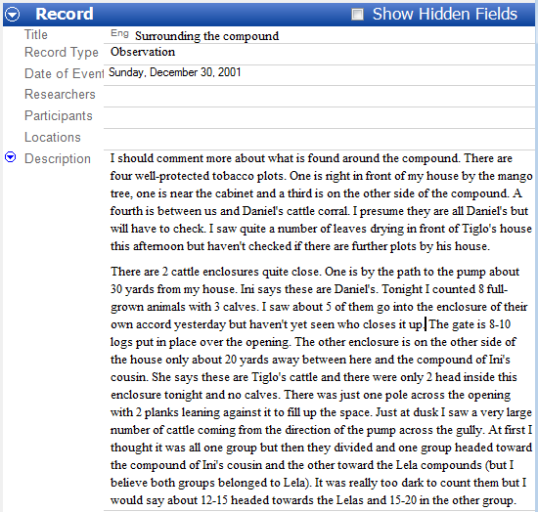
      - In the Description field, click to place the insertion point to the right of the period that comes after the words yet seen who closes it up.

      - On the Format menu, click Apply Style.
      - Click Added Text, and then click OK.
      - Type a space, and then type (I found out it is Mida’s son, Tiwu.) The space to the left of the parenthesis is part of the added text.
When you have finished it should look like the example. Notice the added text is underlined and in green.
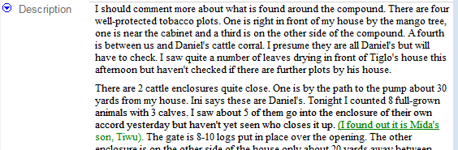

For more practice
In the Exercises go to Module AD and do Exercise 1.

Scenario B: Correcting data
After creating the record Some patriclan activities on 23 February 2002, Ruth finds that she misunderstood a key piece of information, namely that the Tilkha (the fetish) looks after the family, not the field. Ruth wants to keep a record of the misunderstanding, but also needs to correct the error in the fieldnote itself.

Steps to add and delete information in a fieldnote
      - Navigate to the record titled Some patriclan activities. (You can use Find Record on the Edit menu to open the Find Record dialog box.)
      - In the Description field, select the text over the field (but do not select the period).
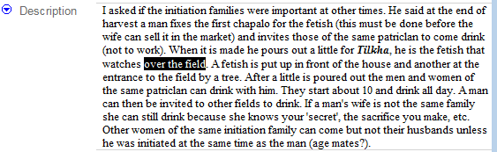

      - On the toolbar, click the down arrow in the Style list.
      - Select Deleted Text. The format for this style is a red strikethrough.

      - In the Description field, click to place the insertion point to the right of the words over the field and to the left of the period.
      - On the Format toolbar, click the down arrow in the Style list.
      - Select Added Text.
      - Type a space, and then type (no, he watches over the family)
When you have finished, it should look like this, with the new text is underlined and in green:

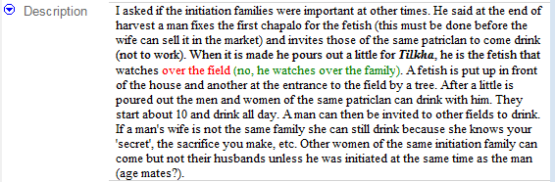

Course Note: If the results of your style settings do not appear as you intended, or the selected paragraphs do not change at all, it may be that direct formatting is applied. Direct formatting overrides default format settings and style settings. You may need to remove the direct formatting. (Direct formatting is removed by first selecting the improperly formatted word or words and then pressing Ctrl + Space bar.)
FieldWorks Language Explorer has the ability for the user to create custom styles beyond the default styles supplied. On the Help menu, click Language Explorer. The FieldWorks Language Explorer Help window appears. Click the Contents tab (if necessary). Expand the Advanced Tasks book (Hint: Click the next to the book). Expand the Customizing Styles book to explore help topics relating to Writing System Styles.

For more practice
In the Exercises go to Module AD and do Exercise 2.

Module DQ: Using Your Data to Generate Research Questions
Learning objective: Be able to type questions in records to guide your cultural study.
FieldWorks project: To do this module, open the Lela-Teli 2 project.
Fieldnotes are a learning tool. Review them often for missing data, and to develop questions and research topics that will increase your cultural understanding.
The Notebook area provides the Further Questions field in order to record questions about individual entries. Use these questions to help guide your cultural study.

Scenario: Recording further questions
A while back, Ruth wrote a record titled The patriclan and adultery dated 23 February 2002. After re-reading this record, she has several questions to ask people about the topic. She would like to keep the questions connected to the fieldnote in order to maintain the context.
Records in Notebook have a text field labeled Further Questions. This is the place to note questions that come from the fieldnote. Ruth writes three questions. Below are the questions she adds to her fieldnote.
Is it the men of her patriclan that pay the goats or hens to erase her 'sin'?
Why is the man involved not seen as being as guilty as the woman? Does he not need any restoration made?
Why is it more serious for a woman to commit adultery with a man from her husband's patriclan? Does it ever occur? What will happen to him or her if it does?

Steps to add further questions to an entry
      - Navigate to The patriclan and adultry record. (You can use Find Record on the Edit menu to open the Find Record dialog box.)
      - In the Record pane, click in the Further Questions field.
      - Type in the questions (above).
      - Check to see if your entry looks like the next illustration.

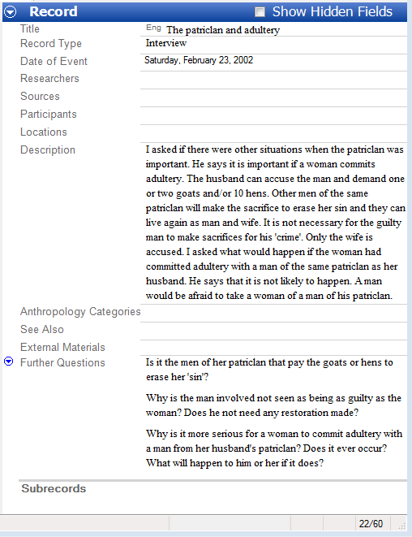

For more practice
In the Exercises go to Module DQ and do Exercises 1 and 2.

Module CE: Categorizing Fieldnote Records
Learning objective: Be able to categorize data with anthropology categories.
FieldWorks project: To do this module, open the Lela-Teli 2 project.

Note on choosing different options among Anthropology Categories
Anthropology Categories in Notebook, FRAME (SIL) and OCM (HRAF), are systems for keeping track of different kinds of cultural topics that are in your fieldnotes. Each category identifies some aspect of culture. When you first begin writing fieldnotes, it may not be apparent why you would need such a system. However, if you collect fieldnotes for any length of time, you will have so much data that finding specific information will be an unmanageable task without some way to sort it out. FRAME and OCM are simply a way of organizing information. Using the system will make it easier for you to find your data at a later date.
Don’t be discouraged by the many category options presented in the Anthropology Categories list (FRAME and OCM). Think of the FRAME and OCM categories as a hierarchy that goes from general to specific. FRAME was designed to make it easier to find OCM categories. Start with the general categories in FRAME and work your way down to the OCM categories.
The OCM is much more detailed, but you can simplify the categorizing task if you start with the 80 plus major categories (codes ending in “0”) before selecting codes from the range of 700 plus subcategories. Each subcategory has a major category “parent”. Each of these, in turn, falls under one of the 11 FRAME categories. If you are unsure whether to use a specific subcategory, then you may want to choose a more general major OCM category. Later, when you are more familiar with the FRAME and OCM system, you can make your categories more specific. There is also an embedded description for each FRAME and OCM category that spells out the kinds of information for which a category is intended to be used. And as long as you use the Anthropology Categories consistently, there is really no right or wrong choice.
It is important to understand that cultural behaviors and events rarely fit nicely into a single category. Cultural behavior typically involves two or more of even the most general categories. This is due to the holistic nature of culture – the fact that different parts of a cultural system are integrated – and is normal. So, rather than worry about whether to categorize an observation with, for example, the major OCM category “420 Property” or “560 Social Stratification,” include them both. Your analysis will be less forced this way, and more accurate and useful in the long run.
Using anthropology categories will turn your fieldnote records into a powerful learning tool. Applying them to your data is a basic form of cultural analysis—the discovery of cultural patterns. It is also the basis for more focused cultural study. The benefit of FRAME and OCM categories is that they are a well-designed system of cultural topics. They are flexible and comprehensive and provide a standard for comparing your data with others.

In the following steps, you will be adding OCM categories to the previously created records. In the following Scenario, you will learn how to use the More and Index features to help you find the appropriate categories. In the rest of the records you can decide what you think are the appropriate categories. Remember that there are no wrong answers. You just need to select categories that will help you find the information again.

Scenario: Adding OCM codes using search and index features
Ruth develops a schedule that allows her to consistently write fieldnotes at the end of the day. Regularly, she takes time to review her fieldnotes and add OCM codes to the Anthropology Categories field.
Soon after writing the record Exploring the Compound, dated 30 December 2001, Ruth rereads the record. She determines there are four cultural topics that apply to the fieldnote.
- Raising chickens
- Preparing food
- Work
- How men and women divide their chores
Ruth’s first task is to find the OCM categories that match, or at least approximate, these topics.
If you do not know which desired categories to add to your record, there is an index and a search feature in the FRAME and OCM Categories Chooser dialog box that will assist you. Clicking the More button in the dialog box displays help information, which can then be used to find an appropriate cultural category.

Steps to add OCM categories to an entry using the index feature
      - To find the Exploring the Compound entry, do the following:
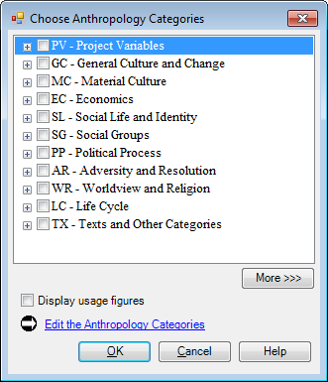
- Click the Find Record icon () on the toolbar.
The Find Record dialog box opens.
- In the Find box, type Exploring, and then click Go To.
      - Click in the Anthropology Categories field.
An ellipsis button () appears.
      - Click the ellipsis button.
The Choose Anthropology Categories dialog box appears.

      - Click More to display to open a pane to the right of the chooser pane.
      - Click the underlined Index hyperlink in the right pane.
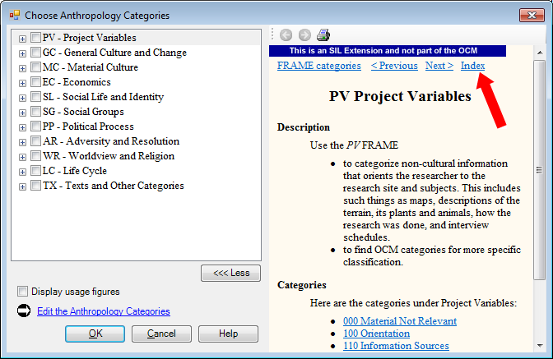

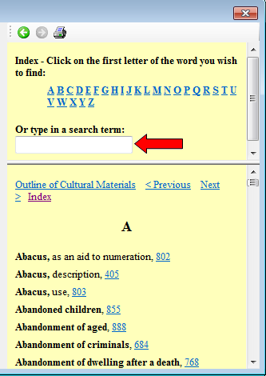

      - Click in the Or type in a search term box.

Until you are quite familiar with the OCM, you will need help finding the right code(s) with which to categorize a fieldnote. The Index is there for this reason. It can help you find the appropriate choice out of the 700 plus possible OCM categories. After you type a word in the search term box, the Index provides several alternatives for you to choose from. If the word you type (chicken) does not yield any choices, try a synonym (poultry). Don’t give up. Sooner or later you will find a category that fits.

Steps to find “raising chickens.”

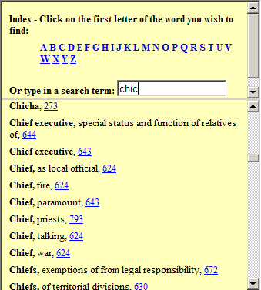

      - Type the letters chic.
      - Scroll to look for chicken. Notice that chicken is not in the list.

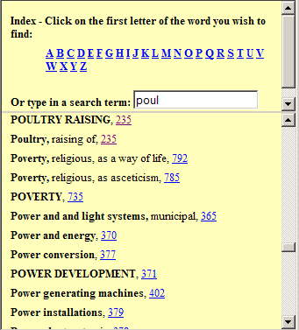

      - Delete chic, and then type poul.
      - Scroll to look for poultry.
      - Notice that POULTRY RAISING is in the list. The code is 235.

      - Click the underlined number 235.
The left side of the dialog box expands and jumps to the category 235 – Poultry Raising.
      - Click the check box to select () 235 - Poultry Raising.
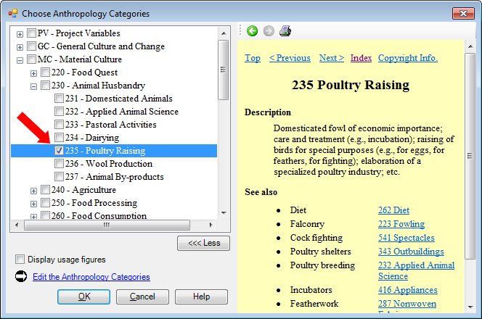

You can navigate through the list manually by clicking the or , or select a category and use the left or right arrows to collapse or expand the categories. Then use the up or down arrows to scroll through the list and select the category you want.

Steps to find “ preparing food.”
      - In the right pane, click Index.
      - Type the letters foo.
      - Scroll to look for food. Notice that FOOD PREPARATION is in the list. The code is 252.
      - Click code 252.
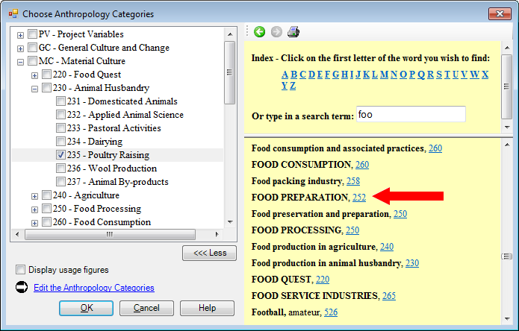

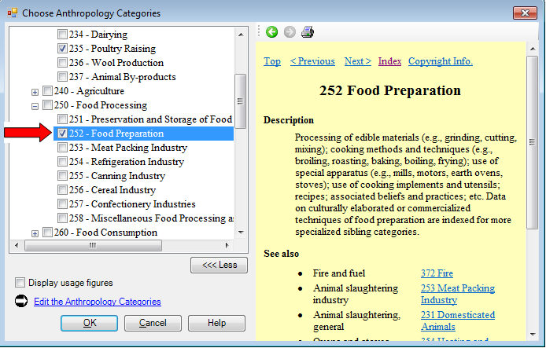

      - Select the 252 - Food Preparation check box.

Steps to find “work.”
      - Click Index, if is not already there.
      - A generic word for work is labor. Type the letter l.
      - Scroll to look for labor. Notice that LABOR AND LEISURE is in the list. The code is 461.

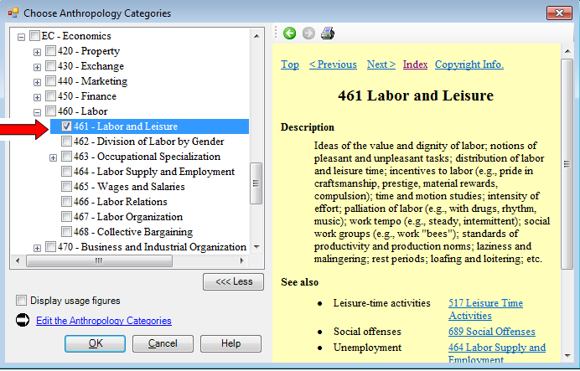

      - Click code 461.

      - Select the 461 - Labor and Leisure check box.

Steps to find “dividing the chores.”
This topic is related to the last one. Fortunately, the category that follows 461 is exactly what you need.
      - Click to select the 462 - Division of Labor by Gender check box.
      - Click OK to close the dialog box.

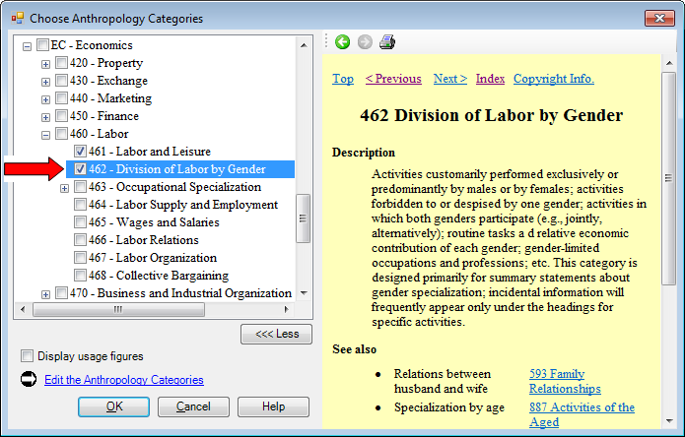

Course Notes: If you had searched the Index for the word chores, you would have come up with 512-Daily routine. For purposes of categorizing, this would have served you equally as well. Remember, there are many appropriate choices.
      - Check to see if your record looks like this:

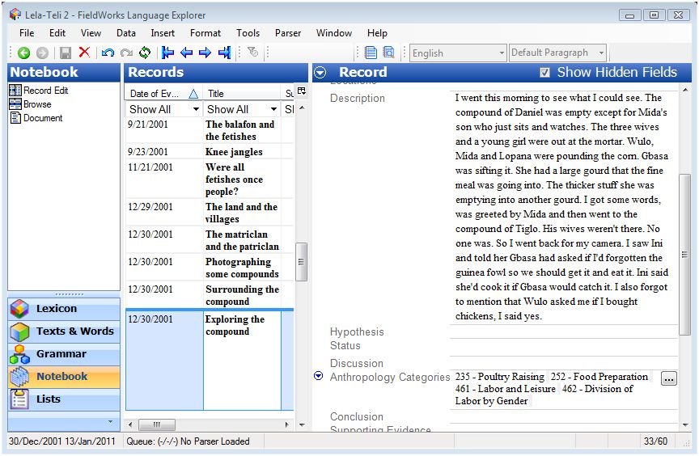

You can click the ellipsis button again to correct your selections at any time.

For more practice
In the Exercises go to Module CE and do at least Exercises 1 and 2.

Module HR: Using Help and Other Resources
This manual is intended to help users get started using Language Explorer. We covered the basics of creating a FieldWorks project, entering and editing data, navigating the different areas and views (panes) of the program, and several other features. However, there is far more that you can do with Language Explorer than is covered in this manual. To help you understand and use the full power of Language Explorer, other resources are provided.

Language Explorer Help
Help is available using the Help menu or using the many context sensitive help buttons in dialog boxes. Help is also available for each data field in the database.

Accessing online help
      - On the Help menu, click Language Explorer.
The FieldWorks Language Explorer Help window appears.
      - Use the Help navigation pane to find the topic you want.
      - Read about the topic in the Help content pane, clicking the hyperlinks as needed to follow the paths to other related topics.

Accessing context sensitive help
Within various dialog boxes and popup menus there are help buttons displayed. Simply click the Help button to bring up the Language Explorer Help window. The topic relevant to the dialog box will appear in the Help Content window.

Accessing help on data fields
There are many data fields available for recording information in Language Explorer. This is especially the case for the Lexicon Edit tool. As you enter data, it may not be clear what a particular field should be used for. To help you with this, full descriptions of each field are located in Language Explorer Help. They can be accessed by right clicking the field label of interest. In the following exercise, we will find help on the Citation Form field.
- Open Language Explorer. Go to the Lexicon, and then click Lexicon Edit.
      - In the Entry pane, right-click the Citation Form field label.
A drop-down menu appears.
      - Click Help.
The Language Explorer Help window appears showing the Citation Form field topic in the Content pane.
Notice the format of the content. Typically, every field description will include: Full name, Abbreviation, Description, Field type, and Writing system used.
      - Read about the Citation Form field and then close the Help window.

Demo Movies
A number of demonstration movies are available to illustrate the major functions of Language Explorer. You may select any movie of interest individually. Or you may opt to watch them all, one after another, in order to get an in depth overview of how Language Explorer works. Each movie is less than 3 minutes long. The entire set can be viewed within half an hour.

Resources
The following resources provide more in-depth detail on various topics. You can access those under the Resources option on the Help menu, or on the start menu: Start\ Programs\FieldWorks Language Explorer\Resources.

Introduction to Lexicography
This document describes some of the concepts, principles, and procedures of dictionary making and how to use Language Explorer to efficiently collect and process dictionary information.

Introduction to Parsing
This document introduces the Language Explorer approach to morphological parsing.

Technical Notes on SFM Database Import
This document gives instructions on how to import data from a SFM database.

Technical Notes on LinguaLinks Import
This document gives instructions on how to import data from a LinguaLinks database.

Technical Notes on Writing Systems
This document goes into greater detail than Language Explorer Help regarding Writing Systems and how to configure them.

Editing Linguistics Papers Using XLingPap
This document describes how to use the XLingPap package as an aid for linguists as they write linguistic papers.

Appendices

Appendix DW - Defining a new vernacular writing system
If you need to set up a new FieldWorks project and also define a new vernacular writing system, we recommend that you give the project and the writing system the name of the vernacular language.
In the following example, the name of the vernacular language is Swati.
      - On the File menu, click New Fieldworks Project.
The New FieldWorks Project dialog box appears.
      - In the Name the project box, type Swati.
      - Under Vernacular language writing system, verify that Swati is not already in the list.
      - Under Vernacular language writing system, click Define New.

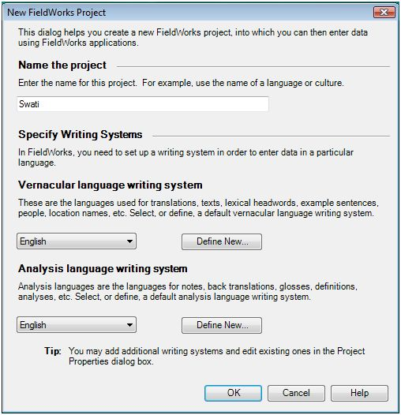

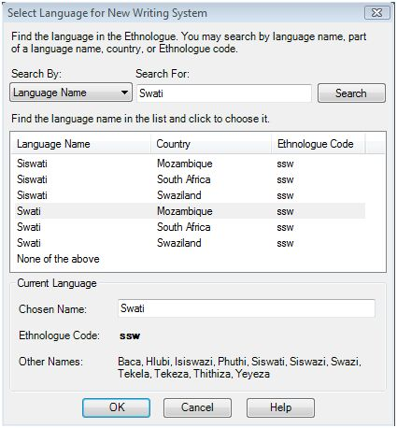
The Writing System Wizard dialog box appears. If the name of the project matches any languages in the Ethnologue, all the matches appear in the list.

      - Select the correct language and country in the list (for example, Swati and Mozambique).

      - Click Next three times.
      - Click Finish.
The New FieldWorks Project dialog box appears again. Under Vernacular language writing system, Swati appears in the list.

On the Writing System Wizard dialog box, click Help. The FieldWorks Language Explorer Help window appears. For more information about defining a writing system, read the Help topic. To read related topics, click the hyperlinks. To see related topics, you can also click the Contents tab of the Help Navigation Pane.

Appendix AC – About Anthropology Categories
The Anthropology Categories field is a list reference field in Language Explorer. The list is comprised of two complementary but distinct topical classification systems for cultural data: Framework for Anthropology and Methodology in Ethnography, or FRAME (SIL International), and the Outline of Cultural Materials, or OCM (HRAF, Inc.).

What is the Outline of Cultural Materials?
The Outline of Cultural Materials (OCM) is a numerical classification system for categorizing cultural data. It was developed by the anthropologist George Peter Murdock and his colleagues for use with the Human Resource Area Files (Yale University). It is usually referred to by its initials, OCM

Cultural classification

Types of categories
In the OCM, there are major categories and subcategories. Both types may be used to categorize data.
There are 83 major categories, which range from 100 to 910. Each major category has multiple subcategories. There are more than 700 subcategories in the OCM.
The first two digits in an OCM code followed by a “0” represent major categories.
Subcategories are represented by the third, or third and forth digits of the OCM code, which replace the “0” of the major category.

Example
A major OCM category and its subcategories:
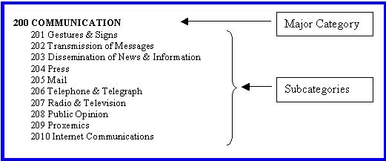

Example
Each OCM category includes a description and cross-references:
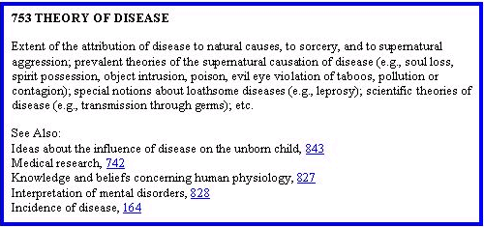

A note about HRAF
The OCM is sometimes erroneously referred to as H-RAF, the HRAF codes, or the Human Relations Area Files system. Although they are related, these should not be confused. The HRAF is a collection of subject-index ethnographic and archaeological data developed for purposes of comparative research. HRAF, Inc. is a not-for-profit international consortium of educational and research institutions. See http://www.Yale.edu/hraf.

Parts of the OCM manual
Here are the parts of the Outline of Cultural Materials:
- Preface and Introduction to the OCM system
- Table of Contents, which lists the major categories and subcategories and their numerical classification codes
- Descriptions of each category with guidelines about what kinds of things can be included under a particular category
- Index of key words cross-referenced to relevant categories

Framework for Research and Methodology in Ethnography (FRAME)

Description
The Framework for Research and Methodology in Ethnography (FRAME) is a top-level outline of eleven subjects under which the categories of the Outline of Cultural Materials (OCM) can be grouped. FRAME was developed by SIL International for use in FieldWorks.
FRAME summarizes and simplifies the more definitive categories of the OCM. It is intended to facilitate access to the OCM for field researchers in the process of language and culture learning. While FRAME categories may be used in research, you are encouraged to use the major categories and subcategories of the OCM when entering data in the Anthropology Category field.

Example of a FRAME category

SG Social Groups
Code and title for FRAME category

Description
Use the SG Social Groups
to find OCM categories for more specific classification about this topic.
to categorize information about how people define family relationships, how family members should interact, marriage, extended families, and kin groups.
How to apply and use FRAME category

Categories
Here are the categories under Social Groups:
570 Interpersonal Relations
580 Marriage
590 Family
Major OCM categories that pertain to the “SG Social Groups” FRAME category
600 Kinship
610 Kin Groups

Appendix SD – About Semantic Domains
The Semantic Domains list is used to categorize lexical entries. You can categorize existing lexical entries by choosing items in the Semantic Domains field. However, you can also use them to collect word using the Categorized Entry tool. This is the reason for the questions and examples included with each list item.

Lexical entries categorized with semantic domains appear in the Classified Dictionary view.

Appendix TF – Title field writing systems
In Notebook, the Title field displays the writing system used in the field. You see this as a three-letter code at the beginning of the field.

Example:
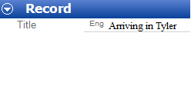

Specifying the Title field writing system
When you insert a record, the Title field usually uses the default analysis writing system that is current at that time. All the fields in the record also use that default analysis writing system. However, the Title field can use another writing system, one that is different from the rest of the fields in the record.
The writing system used in the Title field is set by any of the following:

- The default (top) analysis writing system that was current when the record was added.

- The writing system set in the Find Record dialog box, or in one of the Add Reference dialog boxes when you click Create to insert a new record.

- The writing system you configured to show for the field.

- If you select the entire title and then select a writing system, then that particular field and its contents use that writing system.

Refer to the Help topic Title field (Notebook), and related Help topics for more information.

Return to Insert a Record.

Index

add
subrecords, 69
Added Text, 94, 95
altering data, 93
analysis
writing systems, 89
Anthropology Categories, 100
backup. See data
baseline tab, 26
bulk edit. See editing data
categorized entry. See entry
categorizing records, 100
Choose Anthropology Categories, 100
Configure
Configure Dictionary View, 56
configure columns. See view
configure interlinear. See view
data
backing up data, 39
exporting data (SFM), 60
exporting data (XML), 59
exporting text data, 60
printing configured dictionary data, 56
restoring data, 41
transferring a database to another computer, 55
Deleted Text, 95
descriptions, 85, 93
editing data
bulk edit, 53
editable fields, 6
enter data in a record (Notebook), 65
entry, 17
categorized entry of lexical data, 22
creating a new lexical entry, 14, 17
creating a new text, 24, 25
deleting entries, 16
event
subrecords, 70
export. See data
field, 6
field visibility, 46
fields
Anthropology Categories, 100
Description, 85, 93
Further Questions, 97
FieldWorks project. See Project
filter, 50
filter and sort records (Notebook), 75
find, 47
FRAME, 100, 113
French, 89
grammar area, 6
Help, 32, 107
demo movies, 108
Help menu, 6
Resources, 107, 108
insert a record (Notebook), 64
Lela-Teli, 85
list area, 6
Navigation between entries, 42
Notebook, About, 62
Notebook, Reviewing a lot of fieldnotes, 74
OCM, 111
Outline of Cultural Materials, 111
Open
FieldWorks language project, 8
Outline of Cultural Materials (OCM), 100
pane, 5, 6
customizing pane size, 42
print. See data
Project
new, 8
open, 8, 9
promote or demote subrecords, 72
questions, 97
record
enter data into a record in Notebook, 65
insert a record in Notebook, 64
sort and filter records, 75
records. See also subrecords
research questions, 97
restore. See data
Semantic Domains field, 114
sort, 49
Sort
sort by leading characters, 49
sort by training characters, 49
sort and filter records (Notebook), 75
subrecords
add, 69
event, 70
promote or demote, 72
text
exporting, 60
interlinearize, 26
record, 26
Title field
Writing System used, 115
Title field writing system, 115
vernacular writing system, 85
view
customizing columns, 44
customizing field visibility, 46
customizing interlinear analysis lines, 26
customizing pane size, 42
data entry, 14
display panes or views, 6
writing systems, 109
analysis, 89
vernacular, 85, 109

